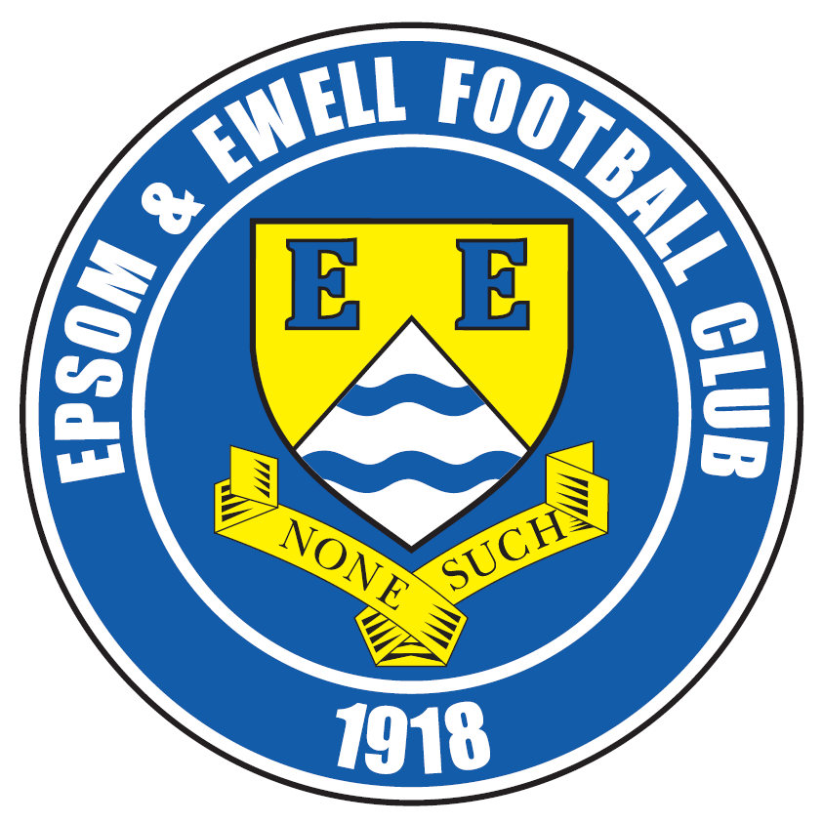 | Epsom & Ewell F.C.  28  v  North Greenford United  Saturday, 22nd April 2017 – 3.00 p.m.
Good afternoon! We welcome the players, supporters and officials of North Greenford United Football Club, today’s officials and our own regulars for today’s final League match of the season.

Our opponents last visited in 2009 when we were still playing at Banstead Athletic and if I’m honest, it’s a surprise to see them here this term. Whilst their relegation from the Southern League last May was not a major shock as they had been flirting with relegation for a few years, it was the transfer by the F.A. which caught our League out, forcing it to operate with 23 clubs for the season. This of course was not the club’s fault, and it will be good to renew acquaintances today.

We were narrowly beaten in the last minute on our visit to Berkeley Fields and whilst this might appear harsh, I thought it was the correct result as we really didn’t get going in the first half against a team that had just changed Managers and were in confident form after having thrashed Chertsey Town 8-0 a few days previously. It would be nice to gain revenge for that defeat though.

We were last at High Road on Good Friday when we hosted Colliers Wood United, and it was a poor exhibition. Whilst I felt a draw was the fairer result, a 92nd minute goal gave them the points. We then visited Horley Town on Easter Monday where we performed much better against our local rivals, winning 2-1 with goals from Rob Hendry and Matt Ferdinando. This leaves us fifth, but if we win today, then both the teams above us would have to win to deny us a top four place and Walton & Hersham visit Hartley Wintney today, eager to redress one of their rare league losses. We still have to do our bit though, or it will all count for nothing. A top four place means a First Round F.A. Vase exemption with two less matches to play, which at an average of three bookings a match could be very useful to avoid!

Quickly looking forward to the League Cup Final against Westfield on Friday 5th May, we are running a coach to Windsor with a price of £10 which leaves from The Kingsway in Ewell Village at 4.30pm, although there will be another stop at Tolworth Railway Station if that is easier. If you are interested, please let a Committee Member know urgently as spaces are filling up!

Today is the final opportunity to return your Player of the Year forms today. They will be available at the gate today and remember that if you are a current club Member your vote counts for double points. Steve Dyke has a list so why not check whether you are paid up, and if not, why not join up, it’s only £6!

Our Presentation Evening is at the Green Man Public House in Ewell at 8pm tonight with a £5 entry charge which will include food. There is still time to attend so just let a Committee Member know if interested.

We hope to see as many of you as possible at Windsor in 13 days, but for those who cannot make it, have a great Summer with no depressing England matches to upset us and we’ll see you in July / August. Remember to keep checking the website for pre-season friendly and other information.

Enjoy the game!

Rich

You can follow us on Facebook: www.facebook.com/epsomandewellfc
Twitter: @EEFCOfficial Instagram at: www.instagram.com/epsomandewellfc
and Youtube at: www.youtube.com/channel/UCtLrpS0x5OaYUACRT34_zng

Today’s Cover Photos by Gemma Jarman – Two of my Seasonal Favourites!

- Michael Eacott in action during our 1-0 win at Abbey Rangers in February

- Matt Farrell concludes the scoring in our 4-0 home win over Knaphill in September


Cherry Red Records Combined Counties League
Premier Division Table 2016/17
inc Tuesday 18th April | P | W | D | L | F | A | Pts | GD | H | A
Hartley Wintney | 43 | 35 | 5 | 3 | 130 | 40 | 110 | +90 | 0-1 | 1-3
Westfield | 42 | 26 | 9 | 7 | 98 | 49 | 87 | +49 | 2-1 | 1-2
Hanworth Villa | 43 | 23 | 9 | 11 | 71 | 46 | 78 | +25 | 2-2 | 0-1
Walton & Hersham | 43 | 21 | 14 | 8 | 69 | 41 | 77 | +28 | 1-1 | 1-1
Epsom & Ewell | 43 | 22 | 10 | 11 | 87 | 55 | 76 | +32 | X | X
Camberley Town | 43 | 22 | 6 | 15 | 84 | 57 | 72 | +27 | 0-0 | 0-2
Horley Town | 43 | 20 | 7 | 16 | 85 | 67 | 67 | +18 | 3-0 | 2-1
Spelthorne Sports | 42 | 18 | 9 | 15 | 76 | 70 | 63 | +6 | 3-2 | 2-2
Abbey Rangers | 44 | 17 | 12 | 15 | 71 | 73 | 63 | -2 | 7-1 | 1-0
Sutton Common Rovers | 42 | 18 | 5 | 19 | 63 | 64 | 59 | -1 | 2-1 | 1-1
Windsor | 43 | 16 | 10 | 17 | 77 | 71 | 58 | +6 | 2-0 | 1-2
Bedfont Sports | 41 | 15 | 12 | 14 | 70 | 75 | 57 | -5 | 5-1 | 3-1
Knaphill | 43 | 18 | 5 | 20 | 80 | 78 | 56 | +2 | 4-0 | 2-1
North Greenford United | 41 | 15 | 10 | 16 | 73 | 72 | 55 | +1 | 22/4 | 1-2
AFC Hayes | 42 | 14 | 9 | 19 | 63 | 77 | 51 | -14 | 2-2 | 0-1
Guildford City | 42 | 14 | 8 | 20 | 74 | 82 | 50 | -8 | 1-0 | 2-0
Colliers Wood United | 42 | 13 | 11 | 18 | 66 | 75 | 50 | -9 | 0-1 | 0-5
Chertsey Town | 43 | 14 | 7 | 22 | 55 | 90 | 49 | -35 | 2-1 | 3-0
CB Hounslow United | 43 | 14 | 5 | 24 | 54 | 80 | 47 | -26 | 1-5 | 2-0
Farnham Town | 43 | 13 | 7 | 23 | 58 | 83 | 46 | -25 | 2-2 | 2-1
Badshot Lea | 43 | 10 | 6 | 27 | 60 | 113 | 36 | -53 | 4-2 | 4-1
Bedfont & Feltham | 43 | 9 | 7 | 27 | 54 | 116 | 34 | -62 | 4-1 | 9-2
Raynes Park Vale | 43 | 7 | 9 | 27 | 43 | 87 | 30 | -44 | 1-1 | 1-1

Lucky Day? – 22nd April
Played 22 - Won 12 Drawn 4 Lost 6 - For 49 Against 34 - PPG 1.82 - Good
Our Club record against today’s opponent
Played 11 - Won 3 Drawn 2 Lost 6 - For 15 Against 20 - PPG 1.00 - Poor
Our Largest wins and losses against today’s opponent
19th April 2008 - W 3-0 - Combined Counties League (H)
1st November 2008 - L 1-4 - Combined Counties League (A)
Their Last Visit
31st October 2009 - Lost 0-2 - Combined Counties League

Latest Results and Fixtures
Combined Counties League – Friday 14th April
Epsom & Ewell | 0-1 | Colliers Wood United
Combined Counties League – Saturday 15th April
AFC Hayes | 0-4 | Knaphill
Bedfont Sports | 3-3 | Abbey Rangers
CB Hounslow United | 1-0 | Walton & Hersham
Chertsey Town | 0-2 | Camberley Town
Hanworth Villa | 1-3 | Horley Town
Hartley Wintney | 2-1 | Sutton Common Rovers
Raynes Park Vale | 0-1 | Bedfont & Feltham
Spelthorne Sports | 2-0 | Farnham Town
Westfield | 4-0 | Badshot Lea
Windsor | 2-2 | North Greenford United
Combined Counties League – Monday 17th April
Abbey Rangers | 0-1 | Chertsey Town
Badshot Lea | 1-1 | Guildford City
Bedfont & Feltham | 0-0 | Bedfont Sports
Camberley Town | 2-3 | Hartley Wintney
Farnham Town | 0-3 | Westfield
Horley Town | 1-2 | Epsom & Ewell
Knaphill | 1-2 | Spelthorne Sports
North Greenford United | 0-1 | AFC Hayes
Sutton Common Rovers | 3-1 | Raynes Park Vale
Walton & Hersham | 1-2 | Windsor
Combined Counties League – Tuesday 18th April
CB Hounslow United | 0-1 | Hanworth Villa
Combined Counties League – Saturday 22nd April
AFC Hayes | V | Badshot Lea
Bedfont Sports | V | Knaphill
Chertsey Town | V | Farnham Town
Epsom & Ewell | V | North Greenford United
Guildford City | V | Bedfont & Feltham
Hanworth Villa | V | Sutton Common Rovers
Hartley Wintney | V | Walton & Hersham
Raynes Park Vale | V | Horley Town
Spelthorne Sports | V | Colliers Wood United
Westfield | V | CB Hounslow United
Windsor | V | Camberley Town
Combined Counties League – Tuesday 25th April
Bedfont Sports | V | Guildford City
Westfield | V | North Greenford United
Combined Counties League – Friday 28th April
Bedfont Sports | V | Spelthorne Sports
Combined Counties League – Saturday 29th April
AFC Hayes | V | Colliers Wood United
North Greenford United | V | Sutton Common Rovers

Milestones
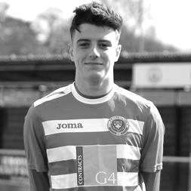
Congratulations go to Jordan Gallagher, our young midfielder, who made his 50th appearance at Knaphill two weeks ago and becomes the 263rd player to reach this mark. Jordan scored on his debut against Gravesham Borough and also becomes the first player to make 50 appearances in their debut season since Sam Currie in 2013. That may not seem too long ago, but it must be pointed out that he is only the 19th player in club history to achieve that mark, and just the fifth this Century after Robbie Burns, Kyle Hough and Paul Borg all did this is in 2007/08. The previous player to do this was Barry Stevens in 1999/00.

Additionally, should Jordan play today and in the Cup Final he will have reached 54 appearances in his debut season, which would place him in joint second place on the all-time list after former Captain Peter Gaydon who made 58 in 1980/81. Four other players have made 54, including Dave Taylor, father of James, back in 1985/86. Jordan has also scored more goals than the other players on 54 appearances.

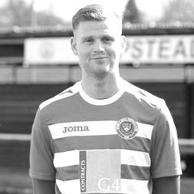
Congratulations also go to Matt Ferdinando who should make his 100th appearance for our club today. Matt made his debut at Knaphill on 20th September 2014 which was also Glyn Mandeville’s first in charge of the team. Since that time he has gained a reputation for scoring some very impressive goals for the club, one of which, the overhead kick against Farnham Town last season was certainly the best I have witnessed in nearly 36 years watching our boys. Matt will become the 121st player to reach the century mark.

Attendances
This season we have had 11 attendances over 100 with a twelfth sure to follow at the League Cup Final. This might not sound like a lot, but as a regular supporter, I thought it was quite good, considering the small attendances we sometimes get. So I thought I’d see when we last had as many. The answer came as a bit of a surprise.

We actually haven’t had so many attendances over 100 since 2003/04 when we had thirty in what was, ironically a relegation season, but more crucially we were members of the Ryman League Division One South with some very large clubs in our Division.

We will play 56 matches this season, our largest number since the 2000/01 season.

Please give generously!
Two of our players James Taylor and Daryl Cooper-Smith are running the London Marathon and we wish them well. If you want to sponsor either or both of them, just go to either of the websites listed below:

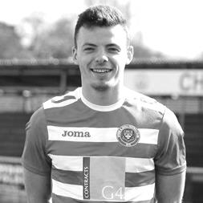
http://uk.virginmoneygiving.com/James-Taylor

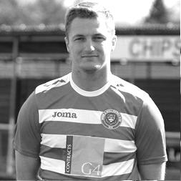
Thank you for visiting my fundraising page and supporting myself and the PSPA charity in memory of Gordon Buchanan-Smith. As many of you know, my girlfriend Rhianna sadly lost her grandad on the 7th September to the heart breaking illness Progressive Supranuclear Palsy after a 3 year battle! The Glaswegian sport fanatic touched all our hearts and will be forever missed. One month later on the 6th October I sadly lost my own hero, my grandad Bill Taylor. I am running the marathon in memory of two amazing men, who I am sure are now enjoying a pint or two together! Thanks, James.

http://uk.virginmoneygiving.com/DarylCooperSmith

Hi!! I have been drafted in to do the London marathon!! So excited to do it for a charity that a friend of ours works for THE RAINBOW TRUST CHILDRENS CHARITY! My group of friends have attended events run by the guys there in the past and have always enjoyed supporting them! PLEASE, PLEASE contribute anything you can to support the guys and myself!!! Thanks in advance, Daryl.

Did you know?
Did you know that we have only used 27 players this season? That sounds quite a lot when you first think about it, but actually, over the fifty-six matches we will play, and bearing in mind injuries, suspensions and players who come and go, that is quite a small amount. How small? Well, on only one occasion in the last thirty years, 1997/98, did we use less than that, when 26 players took the field for a season of 50 matches. In fact we have only used less players than this on seven occasions in club history!!

Ah, but back then we didn’t have substitutes so we were always going to use less players, I hear you saying (if you’re still awake!) So I went back to only count players with a starting appearance, of which there have been 24 this season so far. There are only three seasons in history where we have used less starting players, 1997/98 (21), 1984/85 (21) and 1974/75 (23). All of these were successful seasons, which just goes to show that the old adage about keeping a settled side makes a lot of sense!

From behind the goal
Epsom & Ewell 0-1 Colliers Wood United
Combined Counties League - Premier Division - Friday 14th April 2017

Limp Salts pay the price

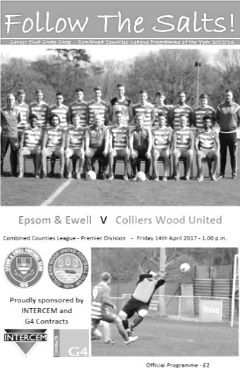
Our realistic challenge for a top four finish was ended by a Colliers Wood team that turned up inside the bottom six and without a regular keeper on Good Friday at High Road in front of 85 spectators; the highest attendance for a home match between the teams. Good Friday fixtures clearly work off the field, but on the field, this result follows our 0-2 loss at home to Westfield last year and we have to hope that the extra day's rest before the Horley trip on Monday is beneficial, or it may become an experiment that isn't worth continuing.

It has to be said from recent performances that this result had been coming. We were fortunate to come away with all three points at Knaphill the week before and this latest defeat means that we have accumulated just four points from a possible fifteen. Third or fourth place was there for the taking after our good run prior to that, but we have fallen away badly in recent weeks. Equally worrying is a sequence I uncovered this week which shows that we have conceded the first goal in our last nine League matches!

It has been a long season and some of our players are beginning to tire as they carry injuries that they should really be resting. Add to that a large amount of player shuffling in an attempt to protect them from the upcoming League Cup Final and maybe it is no wonder we are struggling to get results.

James Taylor and Matt Tanton returned to the starting eleven in place of the absent Craig Hastings and Adam Heagney who was carrying a slight injury. Also in that category was Daryl Cooper-Smith, who started on the bench with but Matt Ferdinando returning to the starting eleven, moving Rob Hendry into Daryl's role. In midfield Reisse Griffin moved from left back to right midfield while Rhys North moved to right back.

The actual match itself was low on quality throughout with neither team able to retain possession for very long. Following our heavy defeat at Wibbandune in August, we were well aware of the threat provided by the visitors strike force, but over the ninety minutes it has to be said that we kept them fairly quiet. Where we let ourselves down was at the other end. Faced with stand in keeper Dan Hughes, a regular outfield player nursing a cold, we failed to test him until the 71st minute. The service to Hendry was poor while the Wood defence, well marshalled by will Boye and Cedric Abraham protected Hughes well from any attempts on goal, including a couple of shots from Jordan Gallagher, which they blocked for corners.

Very little of note occurred in the opening 25 minutes with exception of an early injury related substitution for the visitors. However, the first contentious moment was not far away when in the 29th minute we conceded a penalty. Now I am at the other end of the field when these things happen, but I had quite a good view of Eacott coming across and getting the ball, albeit in an unusual way as he dived in with his feet to do so. There was a minimal appeal and the spot kick was awarded. This looked very harsh from where I was and also begs the question of why big Mike didn't receive a card for his challenge, once the referee had decided that it was a foul. On balance it was a very strange decision. However, Eacott made a brilliant save from the Mario Embalo penalty which was struck hard and low, but a big left hand kept the ball out of the bottom corner.

We improved slightly before the break and Taylor headed a corner just wide at the far post, but we also picked up three rather harsh bookings before the players went off. Firstly, Gallagher was ruled offside and kicked the ball away, despite no visiting player in close proximity, so there was no way he could have been accused of denying a restart in play, this was followed by an even harsher card for Reisse Griffin who quite clearly got the ball on the touchline; something that the Assistant on the sideline could have helped the referee with, had he bothered to consult him. North then picked up a yellow card for alleged persistent fouling. This also appeared undeserved.

The second half also started slowly but there were occasional opportunities. Ten minutes in Eacott had to make a low save while in the 59th minute Hendry set up Griffin who got to the touchline but his pass back didn't find one of our players and the danger was cleared. The visitors were causing us less trouble at this point but still contained a threat and a far post header was sent just wide of Eacott's right hand post before a free kick was headed wide of the other post from a central position. In response Tanton was fouled in the act of shooting (no yellow card obviously!) but Ferdinando's free kick was a weak one and bounced tamely towards the grateful Hughes.

Cooper-Smith entered the fray for Panayiotou which meant the game became a little more stretched. We had added the attacking threat of our leading scorer but moving Ferdinando into a deeper midfield role would not provide quite the same protection at the back. It was a gamble that appeared worth taking and we did start to look more likely to break through. The visitors shot into the side netting but we were beginning to threaten more, that is, when we weren't stopped by a whistle with almost every decision going against us for a spell.

In the 71st minute a clever ball put Cooper-Smith through on goal and his shot was low and definitely going in but Hughes made a superb save to his left to concede the corner. Then substitute Jason Nwachukwu received a good crossfield ball from Cooper-Smith and set up Tanton on the overlap but his low cross was diverted by the leg of Hughes with Cooper-Smith waiting for the tap in.

Our players were becoming frustrated by the number of decisions that were going against them and a clear foul on one of our players in the box was only given on the advices of the Assistant. Eacott conceded a yellow card simply for taking the referee to task about this, and it was easy to have sympathy with that position. We nearly scored with ten minutes remaining when Nwachukwu hooked a cross over from the left and Ferdinando produced a superb volley from outside the box which Hughes again did really well to keep out and he was there again to block a Cooper-Smith shot a few moments later. The visitors responded with a far post header which Eacott saved before he was beaten but Taylor was there to clear the ball off the line.

With two minutes remaining of normal time a long Eacott kick caused panic as the ball was allowed to bounce on the edge of the area. As Cooper-Smith battled for the ball with Abraham and the incoming Hughes inside the box three of our players appealed for a handball simultaneously, but incredibly a free kick was given the other way. I didn't have a great view of this but you can tell a lot just from looking at the players and yet again it looked like we were hard done by. Then in the 92nd minute salt was rubbed into those wounds when Embalo wriggled past a challenge on the left, cut in and fired low below the advancing Eacott to claim all three points with almost the final kick of the match. Instead of probably winning the match we had lost it just in those last few moments. This was incredibly frustrating, but ultimately we didn't do enough to deserve the win and now face two tricky fixtures against Horley and north Greenford with our eggs all firmly placed in the basket marked "League Cup Final". At least we now know that barring any sending offs at Horley or subsequent injuries we will have a full squad available for that contest.

Epsom and Ewell: Michael Eacott, Rhys North, Matt Tanton, Craig Hastings, Alex McKay,
Savvas 'Agi' Panayiotou, Reisse Griffin, Matt Farrell (c), Rob Hendry, Matt Ferdinando,
Jordan Gallagher

Sub: Jason Nwachukwu for North (54), Daryl Cooper-Smith for Panayiotou (67),
Adam Heagney for Gallagher (77)

#
From behind the goal
Horley Town 1-2 Epsom & Ewell
Combined Counties League - Premier Division - Monday 17th April 2017

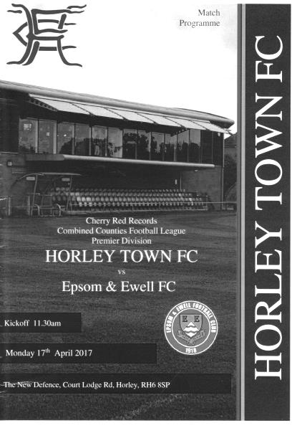
Improving Salts climb to fourth with local derby win

This topsy turvy end to the season might just provide us with a top four finish after all! Following our loss to Colliers Wood United three days previously, I felt any chance of either catching Hanworth Villa or Walton & Hersham was gone, but both then promptly lost, so our 2-1 win at Horley Town has opened up the race once again.

In terms of personnel both Matt Farrell and Agi Panayiotou were missing in midfield for this match, but Alex McKay and Matt Ferdinando did great jobs in the middle of the park. There were also a number of changes at the back as Captain Dan Dean returned as did Craig Hastings and Adam Heagney, while Jason Nwachukwu started up front alongside Rob Hendry.

We made a bright start with a good flick on by Nwachukwu to Hendry but he delayed his shot which was then charged down. Moments later, with the clock showing five minutes a right wing cross came through a crowd of players but the ball then ran straight under Hendry's foot when he was just eight yards out. The home team then had a shot on goal from former Salt Ayden Richards but Michael Eacott was able to make the low save.

The home side pushed on, although Jordan Gallagher was defending deep and was able to clear the danger before then getting a shot in of his own at the other end a minute later, but he was at full stretch and couldn't keep the attempt down. However, we took the lead in the 37th minute when a ball over to the left wing found Ferdinando on the overlap and his dangerous ball in was met with a close range strike by Gallagher. Somehow George Hyde the home keeper was able to pull off an incredible save, but he was unfortunate to see the loose ball fall for Hendry who was able to nod it in from a couple of yards out.

In response both sides had long range efforts but neither were that close to the goal. Ours came from Hendry, while Horley's came from former Epsom legend Kyle Hough who was kept fairly quiet. Concerningly just before half time Ferdinando picked up a yellow card for delaying the restart just seconds after a Horley player had stood in front

of one of our own free kicks. Are we the only team that actually picks up yellow cards for this? It certainly appears so right now, while other teams appear to kick the ball away regularly or fail to retreat without any penalty.

The second half started with a 20 yard drive from McKay which forced Hyde into a decent save before Dean picked up a yellow card for a foul on Hough. The game meandered for a while with little happening but we doubled our advantage in the 64th minute when a good ball from the right was collected by Ferdinando in a central position. His first touch sent him away from the otherwise excellent Adam Pullin and his second drove the ball low into the corner from twenty yards for a stylish finish. It was his last action of the match as he was withdrawn at that point, probably because of the fact he was sitting on a yellow card and would have missed the upcoming League Cup Final had he picked up a second one!

Maybe 2-0 was a little flattering but we had kept the home side at distance for much of the game and probably deserved to be ahead by this point. Hough got a half chance just after our goal but couldn't hit the target with Reisse Griffin, now playing at full back, heading a dangerous cross clear with strikers waiting, but we conceded a corner just after this and in the 75th minute the home team reduced the arrears when a corner wasn't cleared and as the loose ball was headed back in, it was half-volleyed into the goal by Ryan Brackpool from about ten yards out, giving Eacott no chance.

Daryl Cooper-Smith joined the fray in relief of the hard-working Hendry who along with Nwachukwu had put in a good shift. However, we had a scare shortly afterwards when Cooper-Smith fouled a player, only to see Brackpool coming straight at him. He raised his hands to the player who promptly fell to the ground like the proverbial sack of spuds. This was concerning as a red card would have meant our leading scorer would miss the Cup Final, but fortunately the referee was not fooled by the play acting and produced just the yellow card. Having said that, no Epsom v Horley game is complete without a spat of some sort!

It did at least have the effect of livening up the final minutes as the home team pushed for an equaliser but all they had to show for their late efforts was a shot well over the bar in injury time as we defended well in the closing stages.

In summary, this match was similar to recent Epsom games where few chances were created, but there was definitely an improvement on Friday's performance at home to Colliers Wood. There was more energy out there and we were definitely deserved winners, despite the late bombardment. Was this as a result of the extra day's recovery time? It can't have been a negative factor, but more importantly we took our chances and a win at home to North Greenford United on Saturday will almost certainly guarantee a top four finish. It might even get us third with the way results have been going!

Epsom and Ewell: Michael Eacott, Adam Heagney, Matt Tanton, Craig Hastings,
Dan Dean ©, Alex McKay, Jordan Gallagher, Matt Ferdinando, Rob Hendry,
Jason Nwachukwu, Reisse Griffin

Subs: Rhys North for Ferdinando (65), Daryl Cooper-Smith for Hendry (75)

Club Records - 22nd April
Date | Day | Competition |  | Opponents |  | Scorers
22/04/31 | Wed | London League | A | Mitcham Wanderers | 2-1 | R.Marlow (2)
22/04/33 | Sat | Surrey Charity Shield FINAL | A | Woking | 5-0 | J.Jones (2), L.Graves, T.Dunne, J.Gillespie
22/04/35 | Mon | London League | H | Tooting & Mitcham United | 1-1 | H.Pullen
22/04/36 | Wed | Friendly | H | Tottenham Hotspur XI | 3-2 | B.Ruffell (2), H.Pullen
22/04/39 | Sat | London League Cup FINAL | A | Walton on Thames | 0-2
22/04/46 | Mon | London League | H | Walton & Hersham Reserves | 5-3 | F.Adey (2), G.Brogdale (2), S.Scott
22/04/50 | Sat | Friendly | H | Guildford | 4-1 | R.Orford, A.Hodges, E.Watkins, D.Ford
22/04/53 | Wed | Corinthian League | A | Slough Town | 3-3 | B.Goddard, S.Scott, R.Walker
22/04/54 | Thur | Corinthian League | A | Maidstone United | 0-3
22/04/57 | Mon | Corinthian League | A | Dorking | 4-0 | J.Bangs (3), J.Sorensen
22/04/67 | Sat | Athenian League 2 | H | Windsor & Eton | 6-3 | J.Illaszewicz (4), P.Vaughan, T.Stafford
22/04/69 | Tue | Athenian League 2 | H | Herne Bay | 0-2
22/04/80 | Tue | Southern Combination Cup SF | A | Egham Town | 2-0 | T.Tuite, C.Stewart
22/04/89 | Sat | Isthmian League 2s | H | Camberley Town | 3-0 | B.Perkins (2), K.Duffell
22/04/95 | Sat | Isthmian League 3 | A | Horsham | 0-5
22/04/97 | Tue | Isthmian League 3 | H | Hornchurch | 0-3
22/04/99 | Thur | Isthmian League 3 | H | Clapton | 3-0 | A.Boxall (2), K.Webb
22/04/00 | Sat | Isthmian League 3 | H | Southall | 4-0 | B.Stevens (2), J.Hall, S.Grant
22/04/01 | Sun | Isthmian League 3 | A | Egham Town | 2-1 | A.Toppin, M.Kempster
22/04/06 | Sat | Isthmian League 2 | A | Hertford Town | 0-2
22/04/08 | Tue | Combined Counties  Premier Division | H | Egham Town | 2-2 | R.Burns, C.West
22/04/10 | Thur | Combined Counties  Premier Division | A | Chessington & Hook United | 0-0
Historical Decades
23/04/27 | Sat | Surrey Senior League | H | Vickers | 7-2 | F.Behn (2), E.Olley (2), R.Marlow (2), R.Sperring
24/04/37 | Sat | London League | A | R.N.Depot | 4-1 | J.Jones (2 pens), B.Beglan, T.Delventhal
26/04/47 | Sat | London League | A | Ekco | 2-7 | F.Chitty (2)
22/04/57 | Mon | Corinthian League | A | Dorking | 4-0 | J.Bangs (3), J.Sorensen
22/04/67 | Sat | Athenian League 2 | H | Windsor & Eton | 6-3 | J.Illaszewicz (4), P.Vaughan, T.Stafford
21/04/77 | Thur | Athenian League 1 | H | Worthing | 1-1 | T.Wales
25/04/87 | Sat | Isthmian League 1 | H | Southwick | 2-0 | J.Richardson (pen), T.Tuite
22/04/97 | Tue | Isthmian League 3 | H | Hornchurch | 0-3
21/04/07 | Sat | Combined Counties  Premier Division | A | Cobham | 0-3

History Corner – 22nd April
90 years ago this week we were closing in on our second straight Surrey Senior League title and hosted Vickers, the works team from Byfleet, destroying them 7-2. Reg Marlow obviously scored twice, while Ernest Olley and Fred Behn also got two each with founder member Reg Sperring scoring the other goal. Reg’s daughter Elizabeth and son George are both still around and Liz attended the recent match with Walton & Hersham. The League title was confirmed a week later and we would go onto clinch a League and Cup double in mid-May.

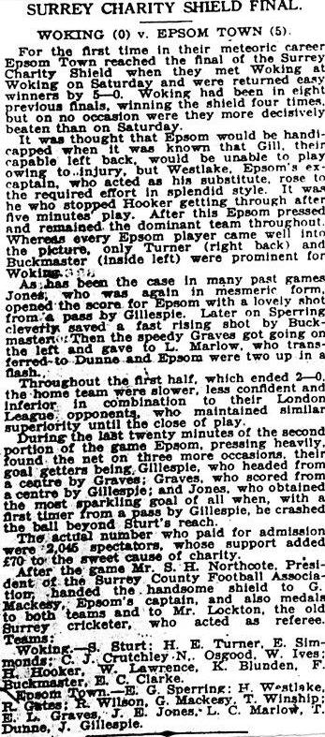
84 years ago today we secured an enormous win, defeating Isthmian League Woking 5-0 on their own ground to win the Surrey Charity Shield Final (see report). We totally dominated the match despite the absence of regular left-back Bobby Gill and goals came from Jimmy Jones (2), Leslie Graves, Tommy Dunne and J.Gillespie.

78 years ago today we visited Stompond Lane for the London League Cup Final. This was an odd one, as it was actually the previous season’s competition, but due to Epsom requiring two replays to dispose of Tilbury in an earlier round, time to play the competition ran out and the League held it over to the following year, at the same time not bothering to start a new competition for 1938/39!

Unfortunately, missing regular keeper, the ill-fated David Wesley, we were defeated 2-0 by the Swans on their own patch.

60 years ago this week Johnny Bangs scored a hat trick as we defeated Dorking 4-0 at Meadowbank. This placed us highly in the League and we went into the final week of the season needing four wins to secure a League and Cup double, but lost the lot and finished fourth!

50 years ago today Jan Illasewicz the son of a former Polish fighter pilot during World War Two scored four times as we defeated Windsor & Eton 6-3. Peter Vaughan and Ted Stafford scored the other goals. Jan was a friend of Player / Manager Tony Williams who knew him from Malvern College and Tony confirmed to me in conversation that in later years Jan would adopt his wife’s name of Bridle as it was less Jewish! He was a great player that also played for Old Malvernians in the Arthur Dunn Cup Final that season, which was the equivalent of the Amateur world’s F.A. Cup Final and also played for Bournemouth for a while.

EL Records Premier Challenge Cup
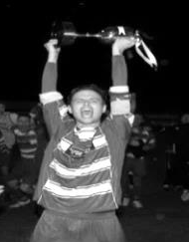
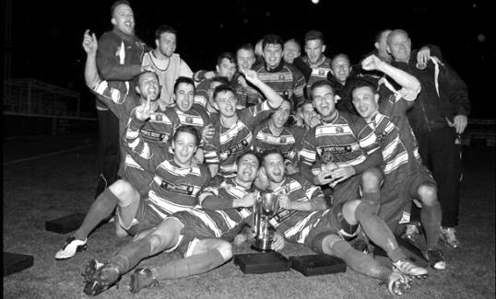
Second Round
Hanworth Villa | 2-4+ | Epsom and Ewell
AFC Hayes | 3-4 | Balham
Epsom Athletic | 1-5 | Windsor
Sutton Common Rovers | 2-1 | Bedfont Sports
Raynes Park Vale | 2-0 | Colliers Wood United
Frimley Green | 1-2 | Banstead Athletic
Westfield | 8-4+ | Redhill
Staines Lammas | 0-1 | Farnham Town
Worcester Park | 8-1 | Cove
Badshot Lea | 0-5 | Guildford City
Chertsey Town | 1-2 | Camberley Town
Cobham | 1-3 | Chessington & Hook United
Hartley Wintney | 4-0 | AC London
Horley Town | 2-2+ 5-4p | Sheerwater
Walton & Hersham | 5-1 | Eversley & California
Ash United | 2-0 | Farleigh Rovers
Third Round
Banstead Athletic | 4-4+ 3-4p | Westfield
Sutton Common Rovers | 1-3 | Walton & Hersham
Farnham Town | 0-4 | Camberley Town
Ash United | 0-2 | Windsor
Raynes Park Vale | 2-1 | Hartley Wintney
Guildford City | 2-1 | Balham
Horley Town | 2-0 | Chessington & Hook United
Worcester Park | 3-6 | Epsom & Ewell
Quarter Finals
Windsor | 2-0 | Horley Town
Guildford City | 1-2 | Raynes Park Vale
Westfield | 4-1 | Camberley Town
Walton & Hersham | 1-3 | Epsom & Ewell
Semi Finals
Epsom & Ewell | 2-0 | Windsor
Raynes Park Vale | 0-4 | Westfield
Final @ Windsor F.C. – Friday 5th May – 7.45pm k.o.
Epsom & Ewell | V | Westfield

Latest Results Grid
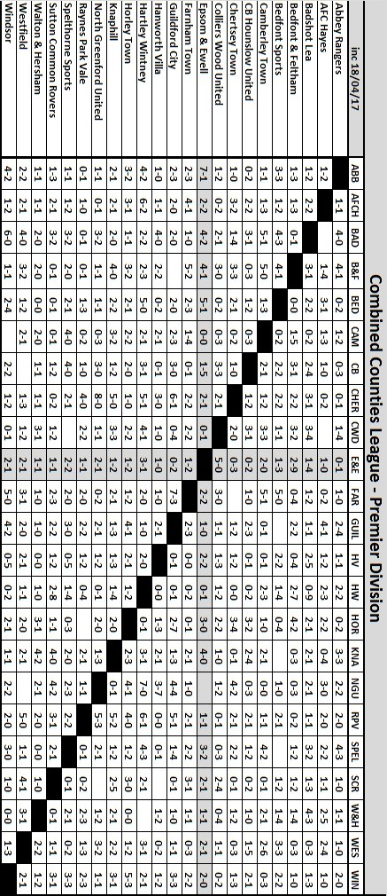

90 years ago!
The 1926/27 season was one of the most successful in our history, probably second only to the 1974/75 season. Not only did we retain the Surrey Senior League title, but we also claimed the League Charity Cup to secure a double.

As current Surrey Senior League Champions it was expected that the battle this year would be between us and the previous Champions Farnham United Breweries who had retained the Charity Cup with a 7-0 win over Walton, the second year in a row they had won the Final by seven clear goals. What no one would have known at the time was that this would be the final season in the Surrey Senior League for both clubs.

In an attempt to strengthen the team this year, Sid Bristow relinquished the Captaincy to Reg Sperring who had held it in the earlier days and in his place came Ernest Olley, late of Dorking, but formerly a member of the Brighton Railway team and a member of a huge footballing family, most of whom had represented the club, although they had dropped out of this level of football in 1925. Also joining was Harry Westlake, a popular and experienced full back. Most importantly moving up from the Reserves was “brother” George Mackesy. He would become a mainstay of our midfield for a decade and a long serving Captain who would go on to make over 350 appearances for the club. The “brother” tag was never properly explained, but his brother Alfred also made his debut the same day and I am assuming slightly that this is where the connection lay.

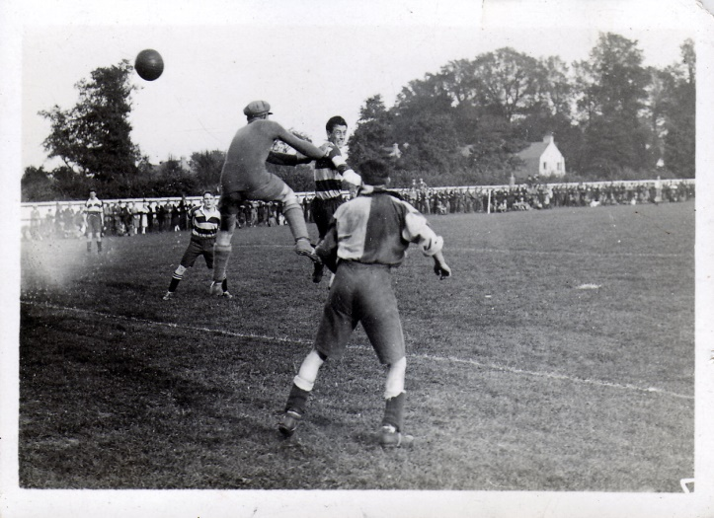
The spine of the team remained the same. From Ernie Sperring in goal, Tom Edwards at full back through to Reg Sperring in midfield and the awesome front line containing Reg Marlow, Jack Parr and Wilfred “Bronk” Challis. And I haven’t even mentioned Freddie Behn, born in Southern Rhodesia, better known now as Zimbabwe. He was a regular for Ewell F.C. but knew Westlake as the pair had previously represented Sussex. He would score at the rate of a goal a game, but this season would be all about Marlow. Our centre forward would score at least 65 goals from 39 appearances, and if I ever find out the four scorers for an end of season win over Godalming, we may well find that he has scored more still!

Doesn’t look like West Street, does it, but this is the far side of the ground in the distance! Reg Sperring scores our seventh goal at home to Walton in our 8-0 surrey Senior League win. The trees would disappear in the fifties and sixties with the new houses being built in Mount Pleasant

The League season started at West Street with a 7-2 win over Addlestone who had surprised Farnham 4-1 in the opening fixture, but disappointment followed a week later with a 3-4 home defeat by London League Tooting Town. This was not a shock as the Terrors were a level above Epsom at the time but we had led at half time, only to concede four times in the first quarter of an hour of the second period. Two late goals almost forced a replay but it wasn’t to be. We drew 1-1 at Krooner Park against Camberley & Yorktown as they were then called before we got into our stride with an 8-0 home league win over Walton (see previous page)

We followed this with wins over Aquarius, the Water Board works team in the Amateur Cup and a 7-0 win over the Westminster Bank in the Surrey Senior Cup. This earned us a trip to Leyland Motors in the Amateur Cup. Leyland had dropped out of the Surrey Senior League this season, which was just as well as they had been responsible for both of our League defeats in 1925/26. They had also beaten powerful teams like Mitcham Wanderers and Wimbledon in the previous two weeks.

They played in Richmond Road, not at the old Kingstonian ground, but slightly further down the road on the other side at the Hawker Sports Centre, which would be used in the fifties by Hawker Athletic and still exists to this day. We were far too good for them though and won easily 5-2.

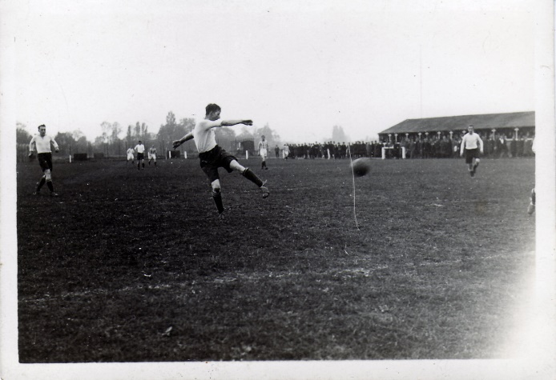
Reg Marlow scores at Leyland Motors

An unfortunate incident occurred at the next match as the club were badly delayed on the way to Farnham United Breweries and once they had arrived, Marlow damaged an ankle early in the game and was just a passenger and then Westlake was sent off for making a jocular remark! Despite this, we still only lost 3-2 against a team that were arguably our closest rivals, so it wasn’t all bad.

Further cup wins against Addlestone (SSC) and Athenian League West Norwood in the Amateur Cup took us to the final qualifying round where we drew out the plum tie of the round, Wimbledon at home! They offered to stage the match at Plough Lane where the attendance would have been enormous but the club rejected the offer and the Herald advised that the crowd "was by far the largest that has been seen on the Epsom ground" an estimated 4,500 crammed into West Street (although the Epsom Advertiser said only 3,000) where a Reg Coleman gave us a half time lead. However, we were unable to hold on and the Dons equalised on the hour with two late goals giving them a fortuitous 3-1 win, and that’s according to the Wimbledon local papers!

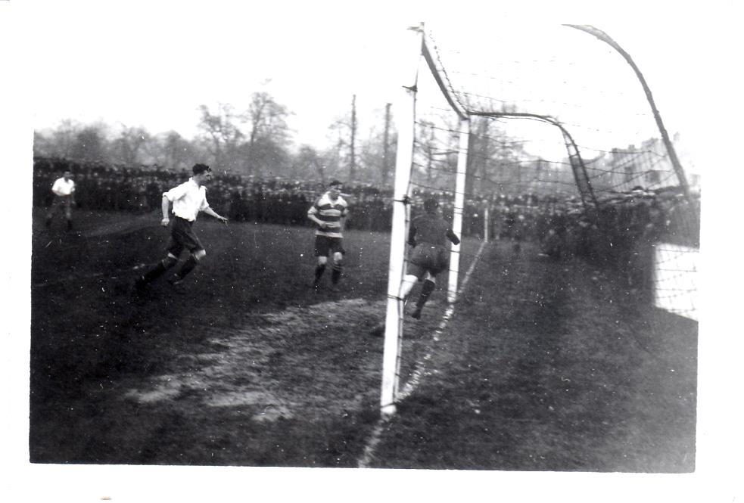
Wimbledon score at West Street. That’s quite a crowd at the top end of the ground!

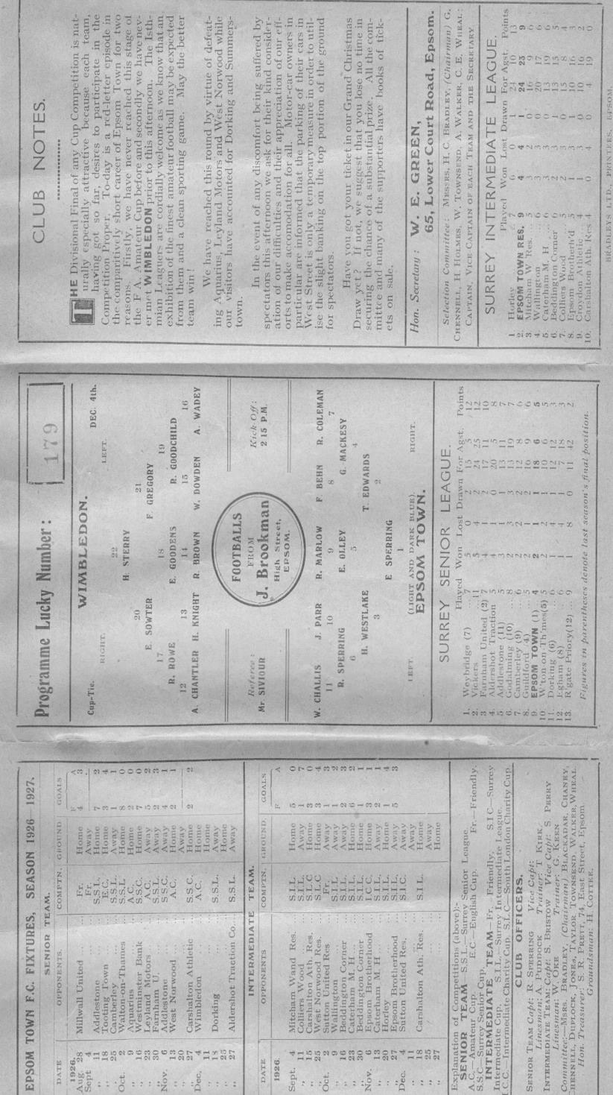

We won Christmas matches against Dorking at home and Aldershot Traction Company away before finally defeating Carshalton athletic in the Surrey Senior Cup in a second replay by five goals to one in front of 1,300. It must be remembered that the Robins were, like Tooting, a London League club. Reg Marlow scored a hat trick in this match to bring his tally up to 32 goals in just 18 matches. However, he was just warming up! He scored four at Weybridge in an 8-0 win and then at home to Guildford both he and Jack Parr got three. We were more than ready for the visit of another Isthmian League club Woking in the Surrey Senior Cup.

Despite the seniority of our opponents, like Wimbledon some three levels above us, we took the lead, even though Olley had arrived late and we had started with just ten men as a result. Marlow was ill and Ernie Sperring also missed just his second match of the season with flu but we held out for half an hour before then conceding six times in fifteen minutes! The lead was extended to 8-1 as an injury to J.Coppin left us with ten men again and although we scored twice towards the end, we were totally beaten, mostly by Joe Perryman who had scored seven of the eight goals. It was only a slight consolation that Woking would go on to win the Surrey Senior Cup that season.

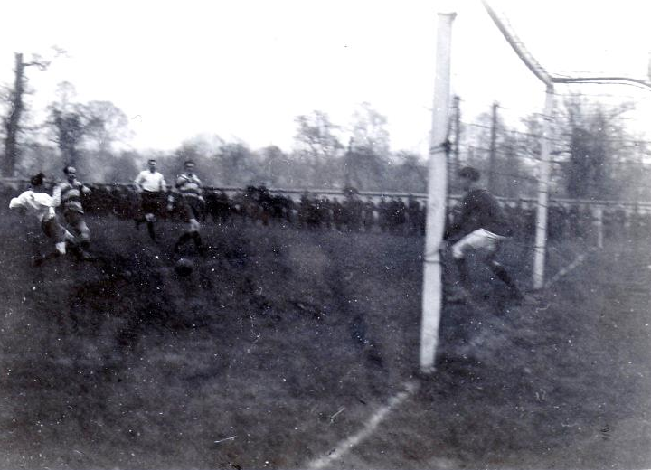
However, nothing would derail us from our main ambitions and Reigate Priory were defeated 7-2 in the opening round of the League Charity Cup with Freddie Behn (bald head, horizontal stripes - below) opening the scoring on his way to a hat trick. Quietly and almost expectedly, Marlow scored another hat trick, his fourth in a row and he extended this to a fifth as we crushed the same team 7-0 just one week later as they returned to West Street for a League match. The press were very impressed with this achievement. In 1952 when Bill Goddard matched Marlow’s feat it was described as a World Record, yet it wasn’t even a new club record!

The run ended at Godalming when he could only score twice in a 5-2 win and we repeated the score a week later when we relieved Farnham United Breweries of the Charity Cup at West Street.

Two more hat tricks for Marlow followed as we crushed Weybridge 10-0 at West Street before confirming that we would repeat as League Champions with a comprehensive 6-3 League win over Farnham United Breweries. Marlow had scored an incredible 28 goals in a ten match span!

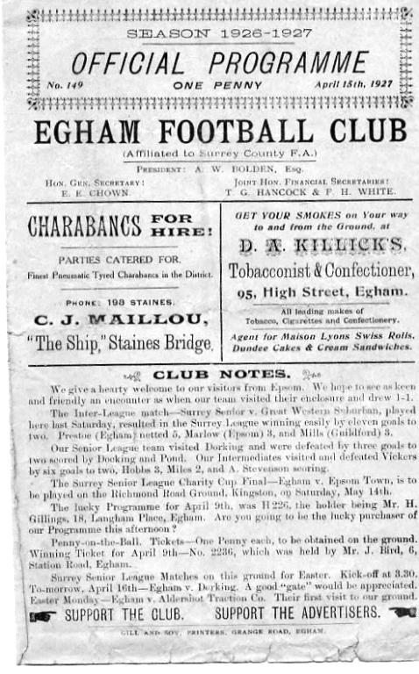
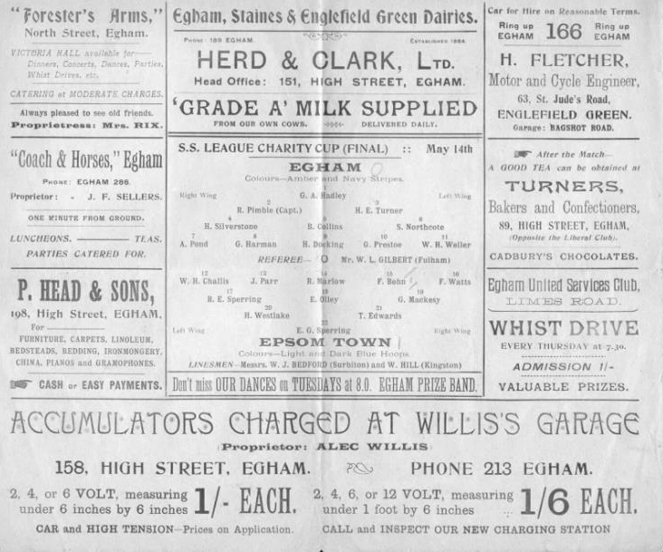
On 19th March a strange situation occurred. Marlow gave us a late lead but Egham equalised in the final moments to secure a draw. It broke our sequence of 20 straight League or League Cup wins at West Street. We took out any frustration on Addlestone, winning 5-0 but were held 2-2 by a reinforced Guildford team with numerous Army players, before winning 7-2 at Reigate Priory. It was the third time we had met and they were probably sick of us by then! We then won 2-0 win at Egham on Good Friday.

We slipped up the next day at home to Aldershot Traction but wins over Vickers (7-2), Walton (3-2), Camberley & Yorktown (3-0), Vickers again (8-0), Godalming (4-1) and Dorking (4-1) confirmed the League title by just two points from the Breweries side. Then on 14th May 1927 a first half Freddie Behn goal was enough to defeat Egham on their own ground to win the League Cup Final and confirm the Surrey Senior double!

For our team the future was bright as we moved onwards and upwards to the London League. For the Farnham side though, it was all over. The Brewery was bought out by Courage and the team folded almost immediately. Harsh!

Above: The programme for our League win at Egham.

Right: the Cup Final programme from 14th May

End of Season Presentation – 2nd May
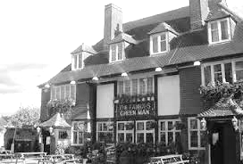
Following tonight’s match we will be having our End of Season Presentation. The event starts at 8pm and will run until fairly late at the Famous Green Man pub in Ewell Village, less than quarter of a mile from our old ground in West Street. This gives everyone plenty of time to get there and still watch the F.A. Cup Semi-Final!

What many of you will not know is that the club used to meet here frequently back in the nineteen twenties and thirties! Before we had a Clubhouse this was the venue for our post-match hospitality with many awards and presentations being made here.

Back in those days the after match festivities were quite grand affairs and were all very formal. I suspect ours will be a little less so!

Tickets are £5 and include food, so if you want to come along and meet the team, just let a Committee Member know!

Ryman League Division One South Table
Incl Monday 17th April | P | W | D | L | F | A | Pts | GD
Tooting & Mitcham United | 45 | 33 | 6 | 6 | 120 | 53 | 105 | +67
Dorking Wanderers | 45 | 32 | 6 | 7 | 102 | 44 | 102 | +58
Greenwich Borough | 45 | 29 | 5 | 11 | 98 | 52 | 92 | +46
Corinthian-Casuals | 45 | 28 | 6 | 11 | 94 | 58 | 90 | +36
Hastings United | 45 | 23 | 12 | 10 | 125 | 61 | 81 | +64
Carshalton Athletic | 45 | 23 | 9 | 13 | 103 | 68 | 78 | +35
Hythe Town | 45 | 22 | 9 | 14 | 86 | 65 | 75 | +21
Lewes | 45 | 23 | 6 | 16 | 88 | 75 | 75 | +13
Faversham Town | 45 | 22 | 7 | 16 | 87 | 56 | 73 | +31
South Park | 45 | 23 | 4 | 18 | 93 | 80 | 73 | +13
Cray Wanderers | 44 | 18 | 10 | 16 | 82 | 84 | 64 | -2
Ramsgate | 45 | 17 | 11 | 17 | 74 | 74 | 62 | 0
Walton Casuals | 45 | 18 | 8 | 19 | 94 | 97 | 62 | -3
Sittingbourne | 45 | 17 | 11 | 17 | 71 | 84 | 62 | -13
Whyteleafe | 45 | 18 | 7 | 20 | 78 | 75 | 61 | +3
Horsham | 45 | 17 | 10 | 18 | 79 | 79 | 61 | 0
Herne Bay | 45 | 13 | 12 | 20 | 74 | 95 | 51 | -21
East Grinstead Town | 45 | 14 | 5 | 26 | 81 | 118 | 47 | -37
Molesey | 44 | 11 | 9 | 24 | 58 | 109 | 42 | -51
Chipstead | 45 | 11 | 7 | 27 | 65 | 96 | 40 | -31
Guernsey | 45 | 9 | 11 | 25 | 66 | 108 | 38 | -42
Chatham Town | 45 | 7 | 9 | 29 | 57 | 120 | 30 | -63
Three Bridges | 43 | 7 | 7 | 29 | 55 | 104 | 28 | -49
Godalming Town | 45 | 8 | 3 | 34 | 48 | 123 | 24 | -75
This season two clubs have battled for much of the season to lift the title, which makes a change from recent years where playoff places were all that were up for grabs after Folkestone and Burgess Hill before them ran away with things. However, Easter results have now confirmed that barring a nine goal swing in the home side’s favour in the final match between the two teams, Dorking Wanderers will be facing the playoff lottery once again, while Tooting & Mitcham return to the Isthmian Premier Division as Champions.

In those playoffs it is good to see Corinthian Casuals after they were robbed last season by a late eligibility issue. At least they will get their chance this time.

At the wrong end of the table Chatham Town, Three Bridges and Godalming Town are all confirmed as finishing in the bottom three. Last year all three of the bottom clubs went down and it looks likely that this will be the case again this year. This means that we will see Godalming Town in our league this coming season.

Our landlords Chipstead have had a narrow escape this term, while even more notably, Guernsey survived by a similar margin. The question of Guernsey is most interesting. The novelty has clearly worn off, and with rumours abounding that they may try to “do a Gibraltar” which makes sense as it would surely be cheaper to undergo half a dozen glamorous European trips instead of 23 mundane matches against South East clubs every other week. I’ll stick my neck out here and say that next season will be Guernsey’s last. Should I be wrong though and they went down next year, I still doubt we would see them, as their assumed home venue of Gatwick Airport places them firmly in the Southern Combination catchment area and Sussex opponents would be their future.

Combined Counties League Division One Table
Incl Monday 17th April | P | W | D | L | F | A | Pts | GD
Banstead Athletic | 33 | 24 | 6 | 3 | 115 | 34 | 78 | +81
Redhill | 32 | 22 | 3 | 7 | 100 | 34 | 69 | +66
Balham | 33 | 19 | 7 | 7 | 101 | 51 | 64 | +50
Chessington & Hook Utd | 34 | 19 | 7 | 8 | 72 | 43 | 64 | +29
Eversley & California | 33 | 18 | 5 | 10 | 85 | 66 | 59 | +19
Bagshot | 30 | 18 | 3 | 9 | 84 | 66 | 57 | +18
Worcester Park | 31 | 18 | 2 | 11 | 89 | 52 | 56 | +37
AC London | 30 | 16 | 11 | 3 | 90 | 37 | 53 | +53
Sheerwater | 34 | 16 | 4 | 14 | 64 | 75 | 52 | -11
Staines Lammas | 33 | 14 | 6 | 13 | 54 | 49 | 48 | +5
Cobham | 33 | 14 | 3 | 16 | 62 | 64 | 45 | -2
Ash United | 33 | 13 | 5 | 15 | 62 | 76 | 44 | -14
Frimley Green | 33 | 10 | 9 | 14 | 56 | 54 | 38 | +2
South Park Reserves | 31 | 7 | 7 | 17 | 62 | 93 | 28 | -31
Dorking | 34 | 7 | 4 | 23 | 48 | 87 | 25 | -39
Farleigh Rovers | 33 | 6 | 5 | 22 | 62 | 118 | 23 | -56
Cove | 32 | 3 | 5 | 24 | 51 | 120 | 14 | -69
Epsom Athletic | 32 | 2 | 0 | 30 | 18 | 156 | 6 | -138
It’s been an incredible season for Banstead Athletic. When they went down in 2012, I thought they would never return as there is no financial support for the football side there anymore. To win the title from that position is even more impressive.

My tips for the title were Redhill and had they not had such a slow start to their season they would have been right up with Banstead to the end. Still, the most important factor is the promotion and we will be returning to Kiln Brow next season.

The third team is not settled just yet but a big Easter Monday 4-3 win for Balham at Farleigh rovers puts them in the box seat. Bagshot can still overhaul them but it must be remembered that they are still awaiting the result of a League Management Decision after they failed to fulfil a fixture earlier this year. This will surely go against them and if it does, then Balham will require a win from their final fixture against Cove today to confirm promotion in their first season. Sharing at Wibbandune, ground grading will not be an issue for them and I expect all three to be competing against us in our upcoming Centenary season.

There are two other things to note here as the season comes to its conclusion. Firstly, Epsom Athletic have resigned from the League to play at Surrey Elite League level once again. This may not appear that relevant but if they were able to get a ground in the Borough that is acceptable for that level, it could be a concern if they start to build a fan base.

Finally, on Saturday 15th April Dorking lost 4-1 at Eversley and California and this was the last match in their history as they have now folded. It’s a very sad end to a club with an enormous amount of history and a cautionary tale for clubs like ours. Dorking Wanderers may take their place as the town club, but the Chicks are no more and it is a very sad day.

Cup Finals
Some of you may have noticed that we have a Cup Final coming up! In fact, on 5th May at Windsor, our club will “come of age” as it celebrates its twenty-first major cup Final.

Finals are frequently difficult matches and it is no surprise to see that we have lost more of them than we have won. Of the previous 20 Finals, we have won only eight.

So I thought I would have a look at them all!

------------------------------------------------------------------------------------------------------------------------------------

Saturday 14th May 1927 – Surrey Senior League Charity Cup – Egham FC 0-1 Epsom Town

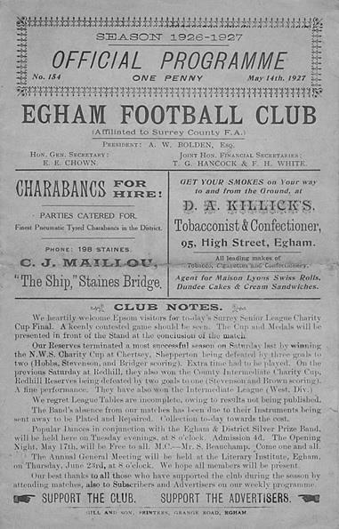
In the post war years, The Charity Cup ran alongside the League Cup as the Surrey Senior League, now of course better known as the Combined Counties League, ran two knockout competitions. These days it only runs the League Cup, but back in the twenties there was only the Charity Cup.

In a 13 team League we reached the Final by virtue of a first round bye before destroying Reigate Priory in the Quarter-Final by 7-2 at West Street. The Semi-Final was against the two-time holders Farnham United Breweries but they were no match as we sailed through to the final with a 5-2 home win.

Maybe understandably after two home draws we faced Egham in the final on their own ground, but in front of 2,000, 400 of which came from Epsom, a Freddie Behn goal in the first half was enough to win the points. However, it was described as a comfortable win and the Egham keeper Harman kept the score down with some fine play.

We never had the chance to defend the Cup as we moved up to the London League, following the League and Cup double of 1927.

Saturday 22nd April 1933 – Surrey Charity Shield – Woking 0-5 Epsom FC

The Surrey Charity Shield was similar to the Surrey Senior Cup except that it was invitation only, and in its earlier years it was the biggest clubs that would usually make up an eight team tournament, although the competition would be devalued in the postwar years with weaker teams entering, largely due to the bigger clubs declining the invitation as they had bigger fish to fry.

We won our first round match in the September of 1932, defeating Carshalton Athletic 2-0 and in the Semi-Final we were drawn away to Sutton United. However, we had already beaten them three times that season, including a 4-1 win in the Amateur Cup and we were able to register a 3-2 win at Gander Green Lane, with two goals from Leslie Marlow and the other from A.T. Rance. It would be 75 years before we would win there again, famously in 2008.

The Final was an even tougher proposition as we were due to face Isthmian League Woking on their own ground, but Jimmy Jones put us ahead on the half hour and Tommy Dunne made it 2-0 just before the break. There was no further scoring until twenty minutes from time when J.Gillespie, followed by Leslie Graves and then Jimmy Jones scored in quick succession to win the match 5-0!

Saturday 14th May 1955 – Surrey Senior Shield – Epsom FC 1-0 Carshalton Athletic

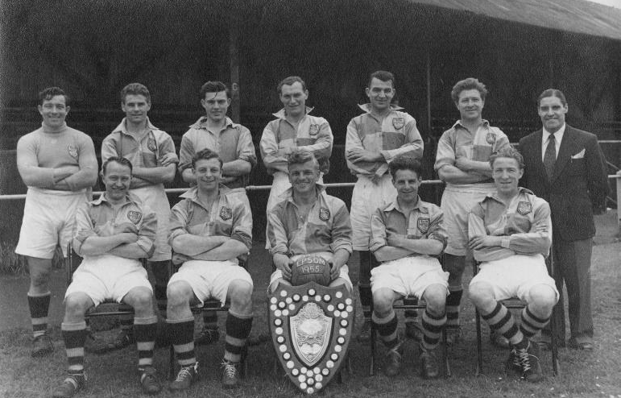
The competition had been renamed by this point and was presumably no longer for Charity but the standard of the teams had also dropped. We had kicked off in the February of 1955 with a 3-0 win over McLaren Sports, a Surrey Senior League team that would change their name in the sixties to Petter Sports and were based in Egham. Ernie Watkins (with Shield) Captains the team to victory

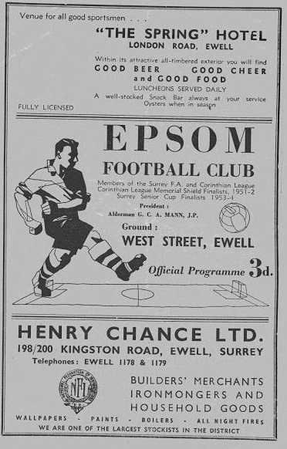
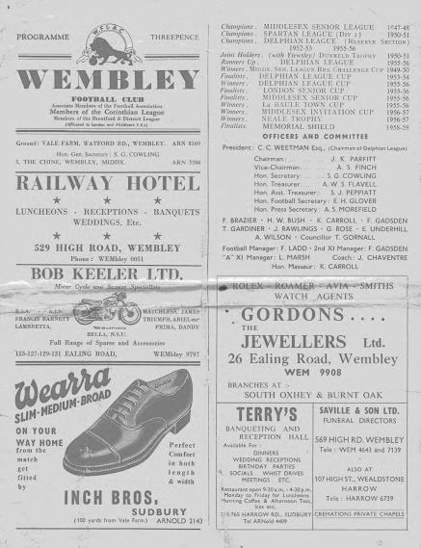
Another team from that League were met in the Semi-Final in our old friends from Camberley and Yorktown as they were then known, where three second half goals turned the match around into a 3-1 win. In the Final, it was our local rivals that were defeated 1-0 at West Street but this was a very disappointing season. Our Manager Pat Lynch had just resigned and our club had just finished bottom of the Corinthian League for the first time, as had the Reserves. This was also the last time that we beat Carshalton Athletic!

Saturday 30th April 1960 – Corinthian Memorial Shield – Epsom FC 2-0 Maidenhead United

This one was all about revenge. We had been in two previous finals of what was the Corinthian League’s League Cup, losing to Hounslow in 1952 and then in 1957 to Maidenhead United. Three years later the two teams met again at Wembley’s Vale Farm and this time it was our turn to win by the same score as we had lost

in the previous final. Steve Dunwoody was allowed leave from his National Service to play and he scored twice to win the match. We had won 3-1 at Erith & Belvedere in the First Round and this was the only goal we would concede as Leatherhead (4-0) and Letchworth (5-0) were dispatched at West Street in the Quarter and Semi-Final respectively.
Peter Wood (with Shield) Captains the team to victory (below)

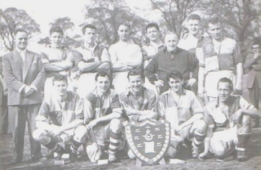

Wednesday 1st May 1974 – Surrey Senior League Cup – Epsom and Ewell 2-1+ Malden Town

Our first season back in the Surrey Senior League after many lean years in the Athenian League, was quite a successful one. Although most people quite rightly think of the 1974/75 season as our high water mark, this season, the first under Pat O’Connell’s Management was quite good too as we finished Runners-Up in the League and then won the League Cup with this extra time victory.

We won 3-0 at Frimley Green in the February of 1974 and then edged our way past Chobham 3-2 at West Street to reach the Semi-Final where we had to visit Wandsworth and required an extra time winner from Colin Rose after the teams had been level at 1-1 after 90 minutes. The Final at Stompond Lane Walton & Hersham was goalless after 90 minutes but of all players it was full back Alan Webb that broke the deadlock and Rose scored a second before a late consolation.

Wednesday 23rd April 1975 – Surrey Senior Charity Cup – Epsom and Ewell 3-1 Virginia Water

This Final was played at Fetcham Grove, Leatherhead and because of our hugely successful season, had played at Wembley Stadium just four days previously and then won 9-0 at Whyteleafe on the Monday! To reach the Final we had beaten Chobham once again, this time 3-0 at West Street, and then 3-1 at Worplesdon and 3-0 at Horley Town in the Semi-Final. The Final was against the only team that had defeated us in the League all season, and Virginia Water managed to score against us on all three occasions that we met, which was no mean feat in a season of such dominance, although it should be pointed out that their goal in this final came from their only shot on target, a penalty awarded four minutes from time. In both of these seasons there was the Charity Cup available, the cup we had won back in 1927, but our hopes of winning it again were ended in a Semi-Final replay the first time and by Chessington United 4-3 in the 1975 Final at Chertsey Town.

Monday 20th April 1981 – Surrey Senior Cup – Epsom and Ewell 2-1 Woking

Peter Gaydon lifts the Surrey Senior Cup

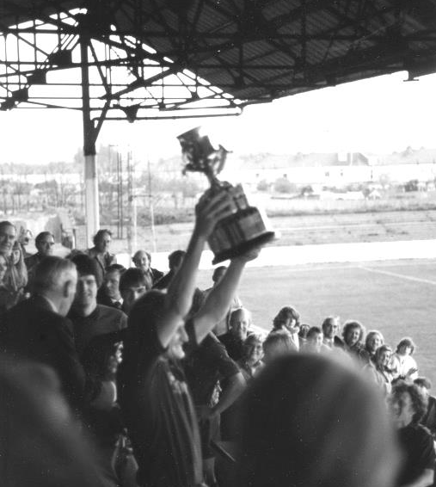
Arguably the greatest win in the club’s history, we won the Surrey Senior Cup for the first and so far only time with a 2-1 win over Isthmian League Premier Division Woking at Sandy Lane, home of Tooting & Mitcham United. We were a good team that season and missed out on promotion that season to three time F.A. Vase winners Billericay Town and F.A. Trophy winners Bishops Stortford, although neither of those teams beat us in either League fixture.

Our journey started back in the final Qualifying Round in December of 1980 when we scraped past Surrey Senior League Westfield 2-1 with an own goal, but cruised past Ash United 6-0 on their own patch before meeting Walton & Hersham who we defeated at West Street 4-2 in a replay after a 1-1 draw, and in the Semi-Final we beat the other F.A. Trophy Finalist Sutton United 3-2 again in a replay after drawing 0-0 at Gander Green Lane.

In the Final, goals from Tommy Tuite and Mick Stratford gave us the lead and the opposition were down to ten men after this for violent conduct but pulled a goal back with ten minutes remaining. It didn’t matter though as Woking were overrun and we were deserved winners.

Friday 10th May 2013 – Combined Counties League Cup – Epsom and Ewell 3-0 South Park

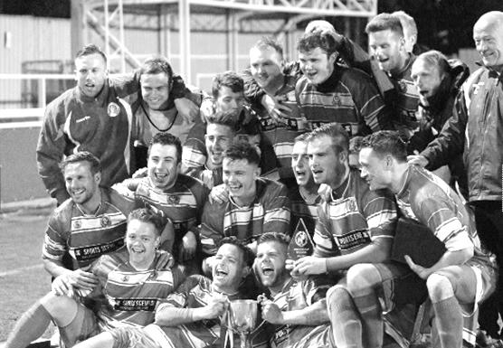
We had to earn this one, our first trophy for 32 years, the hard way, from a 3-2 victory with ten men at Farnham Town in the First Round to a 3-0 win at Bedfont Sports and then a 2-0 win over the mighty Guernsey in the last 16, before easing past AFC Croydon Athletic 6-2 and defeating League Champions Egham by a goal to nil on their own patch and again finishing with ten men, we saw goals from our joint strike force of Robbie Burns and Kyle Hough in the first half before a superb strike by Sam Currie in the second half eased any remaining nerves. Can we win this trophy for the fourth time? You’ve got to be there to find out!

Centre page for results

Centre page for results


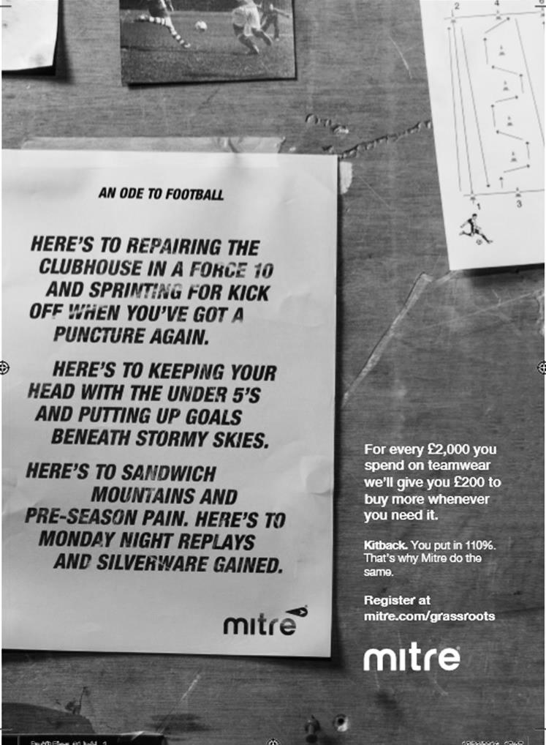

North Greenford United – History
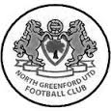
The club was founded in September 1944 as a youth team.

The following season saw the formation of a senior side and the club entered the Harrow League in 1947 and later the Middlesex County League. In May 1983 promotion was gained to the Spartan League with the club joining the Premier Division in 1988, but then resigning in 1994 to rejoin the Middlesex League. Keen to regain Senior Status, ground improvements were undertaken, including the installation of floodlights at Berkeley Fields, and in 2002 the club was elected to the Combined Counties Premier League.

In 2003/04 the club, managed by Steve Hawkins, were runners up in the Premier Challenge Cup losing 4-1 to AFC Wimbledon in front of a crowd of over 5,000 at Woking FC. In season 2004/05 the club finished runners up and in the following year finished 13th as well as reaching the semi-final of the League Cup. The following season 2006/07 saw the team, under Mick Harvey, go one round better, unfortunately losing 4-1 to Merstham in the final.

Steve Ringrose took over the Manager’s job at the beginning of season 2008/09. In his first season Steve led the team to second place in the Premier League with the club finishing Runners-up to Bedfont Green. Season 2009/10 proved the most successful in the club’s history when the First Team became Combined Counties Champions, earning promotion to the newly-formed Southern Football League Division One Central, as well as winning the MFA Charity Cup beating Enfield Town 1-0 at Hampton & Richmond’s ground in front of a large crowd.

Despite having a difficult first season at the higher level the First Team succeeded in retaining its Step 4 status. However, despite notable cup successes, the first half of season 2011/12 saw the club struggling in the league. Steve Ringrose was replaced by Neil Shipperley in December 2012 and Shipps managed to successfully steer the side away from the threat of relegation.

Experiencing an even more difficult time at the start of season 2012/13, Neil Shipperley was re-appointed for a second term replacing Jon-Barrie Bates as First Team Manager at the beginning of October. However, the team continued to struggle and, having lost 14 league matches on the trot, our only consolation was that Woodford United had still failed to notch up a single point. Our campaign that year was saved by an amazing end-of-season run which saw the team finish above the relegation places in 19th place.

We were hoping to continue where we left off at the start of the following season’s campaign but, again after excellent cup runs, we struggled in the league and narrowly escaped the drop after crucial wins against our two fellow relegation contenders, Chertsey and Ashford Town (Middx). Reserve Team Manager Paul Palmer, supported by

Don Bennett, replaced Neil Shipperley following Neil’s resignation midway through the season.

Following an indifferent start to the 2014/15 campaign it was decided to part company with Paul and ask Don to take over. Results though did not improve and in December 2014 Don tendered his resignation. Reserve Manager Barry Morris took over in a caretaking capacity assisted by coaches George Bouhet and Fitzroy McLeod.

After an initial struggle another impressive end-of-season run saw the team finish four points clear of bottom club AFC Hayes, and we were granted a reprieve by the FA. Barry and his team were re-appointed on a permanent basis for the forthcoming campaign, but in September 2015 Barry resigned due to work commitments, and George accepted the position of Acting First Team Manager.

Once again, unfortunately, poor results left the club firmly rooted at the bottom of the Central Division, and in November 2015 the committee appointed two ex-Greenford players – Ricky Pither and Danny Bennell – as joint First Team managers to replace George. Despite some promising performances, results still did not improve significantly. In the end four wins and six draws were not enough to secure the points needed to avoid the drop. On this occasion, a strong end-of-season run could not be achieved and the team ended their campaign well adrift at the foot of the table. There was to be no chance of being granted another reprieve.

When relegation was confirmed we expected to be moved to either the Spartan South Midlands or Combined Counties League. It therefore came as a shock when the FA announced its decision to place the club in the Hellenic League. Given the serious implications of such a move, both in terms of travel costs and player recruitment, the Committee decided to mount a formal appeal. Eventually the appeal was upheld and we were offered a place in the Combined Counties Premier Division, even though for one season the league would have to run with 23 clubs.

Given their wide knowledge of local clubs and players, Ricky and Danny’s team were invited to continue in their roles with Mark Chandler taking over as joint manager following Danny’s resignation. Unfortunately, due to poor league results which left the club languishing at the foot of the CCL Premier Division table, the NGU committee reluctantly decided to part company with Ricky and Mark at the beginning of October 2016.

The experienced management team of Danny Vincent and Colin Murphy were offered and accepted the position, and were duly appointed in time to take charge of the Chertsey Town home game on 11th October. This had an instant benefit with an 8-0 win over their fellow relegation candidates and a 2-1 home win over Epsom & Ewell marked the start of a good run that took the club away from the danger zone.

The club looks forward to 2017/18 when they hope to challenge at the other end of the table, but it which division that will be, only time will tell, as they sit on the border between the three Step Five Leagues and could easily be the ones to move as the Combined Counties League reduces back to twenty-two clubs.

Every Opponent A-Z

Over the years we have played many, many different opponents. Exactly how many is a difficult question, as it all depends on your definition. Are Camberley & Yorktown different to Camberley Town, or are Epsom Town different to Epsom F.C. or Epsom & Ewell F.C.?

In my analysis I have classed both of the above examples as the same team, and will work through them all from A to Z. Some we have played many times, whilst others we have met just once or twice. Enjoy!

Walton and Hersham: Played 52 - W25 D11 L16 - F105 A99 - PPG - 1.65 - Above Average &
Walton and Hersham Reserves: Played 2 - W1 D0 L1 - F8 A10 - PPG - 1.50 - Average

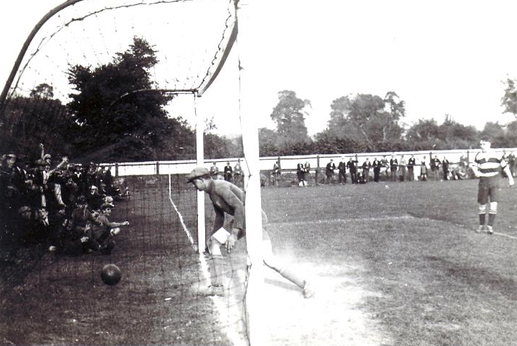
These two teams have recently passed their fiftieth first team meeting, with our first coming on the 22nd November 1924 at Walton’s old ground in Mount Felix, which was situated nearer the town centre of Walton than their current ground. On that day the game was drawn 2-2 but Epsom Town were to have the upper hand in early matches between the teams, including a 5-0 win on 20th February 1926, and then an 8-0 win on 2nd October 1926, both games being played at West Street. The photo (above) shows the Blues scoring one of their eight in the lower goal that day. In six Surrey Senior League matches to 1926/27, we won four and drew two.

We did not meet again until 1937/38 season, when we won twice at West Street, once by 3-1 in the F.A.Cup and the other by two clear goals in a London League match, with the return game at Stompond Lane finishing 2-2.

However, this run was about to end. In 1938/39 the two teams met three times in sixteen days, with Walton winning for the first time 2-1 at home, and although Epsom returned the favour with a 5-3 win at West Street there was another more important match to come. On 22nd April 1939 the London League Cup Final was held at Stompond Lane, and goals after 40 and 55 minutes sent the trophy to our opponents in a game described as “flat as dishwater” by our local papers, who obviously took the defeat well!

Our only connection with Hersham was a wartime one, with Epsom Town, who used our ground from 1939/45 defeating them 4-2 and 5-0 in 1939/40. Epsom won the Surrey Combination that season with Walton second, and both moved to the South Eastern Combination for 1940/41 while Hersham closed down, only to return in 1945 as part of the newly merged Walton & Hersham.

The boot was firmly on the other foot now as Walton, under future Manager Bill Kennedy won the

Corinthian League three times in a row in the late forties. They also defeated our boys 9-1 in the London Senior Cup in 1945 and even their London League team, effectively their Reserves, defeated us 7-3 that year, although we won the return League game at West Street 5-3.

In January of 1949 we were defeated 5-0 in the Surrey Senior Cup, but joined them in the Corinthian League the following season. We technically stopped them from making it four straight titles as we beat them 3-2 at West Street in August 1949, and although they returned the favour in March 1950 by five clear goals, they missed the title by a point from Hounslow.

With their star in the ascendancy for quite a while, we did not meet again until1977 when they won a replayed F.A. Cup match 2-1 at West Street, but we were on their way up to the Isthmian Division One where the Swans were by now languishing. Over the next six seasons to 1984 we would meet seventeen times, twelve of these in the League, (winning seven of them) and five in various Cups, including the Southern Combination Cup Final of 1982/83, which was held over, but eventually won by Walton & Hersham on penalties after a 1-1 draw in the August of 1983.

Our promotion to the Isthmian Premier Division kept us apart for two seasons, and results were shared when we returned to Division One for 1986/87, although our second relegation meant that we would meet only sporadically over the next decade, winning three Southern Combination Cup ties and a Surrey Senior Cup match, but losing an F.A. Cup game 5-1 at West Street in 1991.

In 2002 we were briefly back up at Isthmian League Division One South level, and we drew 0-0 at Stompond Lane, winning the home League match 1-0, but in our horrible relegation season of 2003/04, we lost 3-0 at home, and embarrassingly 8-0 away in a match badly affected by the early sending off of our keeper Dave Hyatt, which remains our worst defeat since 1968 when we conceded ten at Lewes. We then met in a Surrey Senior Cup tie in January 2010 where we trailed early, but aided by two stunning goals from Jamie Hatfield we led 4-1 at the half. However, a second half collapse left us level at 4-4 and we lost 5-4 in extra time.

Until this season that had been our last meeting, but we marked the 50th match between the clubs with a 1-1 draw at Stompond Lane in October with Alex McKay putting us ahead. Of course, in our recent meeting in January he put Walton and Hersham ahead with an own goal, but we recovered to win 3-1 and recorded another 1-1 draw in March when we met for the 52nd time.

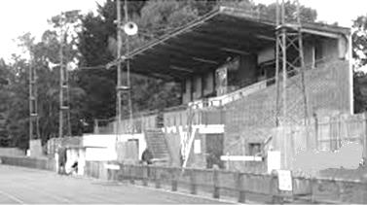
The historic main stand at Stompond Lane. Get there soon as time is running out to see it!

Match and Ball Sponsorships – 2016/17
Opponent | Date | Match Sponsor | Ball Sponsor
Gravesham Borough | 07/08/16 | Club President - Stella Lamont
Gravesham Borough | 07/08/16 | Relocation Committee Member - Mike Lovett
CB Hounslow United | 16/08/16 | EEFC Management Committee
Abbey Rangers | 23/08/16 | Steve & Geoff Dyke
Horley Town (11.30am) | 29/08/16 | In Memory of Chris Henry
Abbey Rangers (LC) | 06/09/16 | Paul Merritt
Camberley Town | 10/09/16 | Building Shop Ltd
Knaphill | 24/09/16 | EEFC Holding Company Director – Pete Lumm
Bridon Ropes (FAV) | 22/10/16 | George and Joseph Saunders
Sutton Common Rovers | 08/11/15 | Alex McKay Senior
Abbey Rangers (FAV) | 13/11/16 | EEFC Holding Company Director – Dave Ellins
Windsor | 15/11/16 | In Memory of Wally Dyke
Bedfont Sports | 19/11/16 | John Bonner
AFC Hayes | 26/11/16 | Jack Jarman
Chipstead (SSC / DWT) | 06/12/16 | Trevor Stotten
Hanworth Villa | 13/12/16 | Roger and Carol Farrell
Chertsey Town | 17/12/16 | Kansei Engineering
Raynes Park Vale (11.30am) | 27/12/16 | In memory of Dave and Liz Marshall
Spelthorne Sports | 07/01/17 | Building Shop Ltd
Guildford City (SSC) | 10/01/17 | Super Six Winner – Rita Christian
Guildford City | 17/01/17 | Kansei Engineering
Badshot Lea | 04/02/17 | Kansei Engineering
Westfield | 18/02/17 | Tony Coome
Walton & Hersham | 04/03/17 | Super Six Winner – Rita Christian
Bedfont & Feltham | 07/03/17 | Programme Editor - Richard Lambert
Hartley Wintney | 18/03/17 | Kansei Engineering
Windsor (LC SF) | 21/03/17 | In memory of Bob Bexley
Farnham Town | 25/03/17 | In memory of Jean Bexley
Colliers Wood United (1pm) | 14/04/17 | Steve and Geoff Dyke
North Greenford United | 22/04/17 | Club President - Stella Lamont
For League, League Cup and Surrey Senior Cup Matches:
Match sponsorship - £40.00 Match ball sponsorship - £25.00. Combined £55.00.
For F.A. Cup and F.A. Vase matches:
Match sponsorship - £50.00 Match ball sponsorship - £30.00. Combined £65.00.

Sponsorship includes: (x2 for match, x3 for match and ball)

Admission, programmes, hospitality and advertising and mascot for the day (if required).

If you are interested, just speak to a Committee Member, or drop me an email at: richard.c.lambert@gmail.com


We also thank our Sponsors INTERCEM and G4 Group

First Eleven Appearances 2016/17 - (max 54)
Name | Debut | 2016/17 |  |  |  | Career Totals
Name | Debut | App | Sub | Total | Goals | App | Sub | Total | Goals
CLARK-GLEAVE Charlie* | 23/08/2016 | 3 | 2 | 5 | 0 | 3 | 2 | 5 | 0
COOPER-SMITH Daryl | 03/01/2015 | 34 | 7 | 41 | 31 | 64 | 15 | 79 | 51
DEAN Dan | 02/08/2014 | 39 | 2 | 41 | 2 | 107 | 6 | 113 | 4
DEWAR Ali | 29/10/2011 | 0 | 5 | 5 | 0 | 55 | 40 | 95 | 10
EACOTT Michael | 02/08/2014 | 45 | 0 | 45 | 0 | 130 | 1 | 131 | 0
FARRELL Matt | 02/08/2014 | 49 | 0 | 49 | 17 | 135 | 4 | 139 | 35
FERDINANDO Matt | 20/09/2014 | 31 | 9 | 40 | 11 | 84 | 15 | 99 | 25
GALLAGHER Jordan | 07/08/2016 | 39 | 13 | 52 | 13 | 39 | 13 | 52 | 13
GRIFFIN Reisse | 08/08/2015 | 43 | 7 | 50 | 3 | 71 | 13 | 84 | 5
HASTINGS Craig | 08/08/2015 | 33 | 7 | 40 | 2 | 70 | 11 | 81 | 2
HEAGNEY Adam | 16/08/2016 | 36 | 8 | 44 | 1 | 36 | 8 | 44 | 1
HENDRY Rob | 08/08/2015 | 38 | 10 | 48 | 11 | 68 | 21 | 89 | 23
MCKAY Alex | 20/12/2008 | 22 | 7 | 29 | 4 | 130 | 37 | 167 | 12
NEALE Tom* | 13/10/2015 | 6 | 5 | 11 | 7 | 22 | 24 | 46 | 17
NORTH Rhys | 16/08/2015 | 6 | 4 | 10 | 0 | 23 | 11 | 34 | 1
NWACHUKWU Jason | 01/10/2016 | 16 | 15 | 31 | 1 | 16 | 15 | 31 | 1
PANAYIOTOU Savvas | 03/01/2015 | 44 | 5 | 49 | 5 | 76 | 13 | 89 | 12
PRICE Matt* | 23/08/2016 | 2 | 0 | 2 | 1 | 2 | 0 | 2 | 1
ROBINSON Sam* | 22/10/2011 | 7 | 1 | 8 | 1 | 61 | 6 | 67 | 14
ROSE Daniel | 25/10/2016 | 2 | 5 | 7 | 0 | 2 | 5 | 7 | 0
SALEH Mennar* | 24/09/2016 | 0 | 2 | 2 | 0 | 0 | 2 | 2 | 0
SMITH Matt | 08/08/2009 | 0 | 3 | 3 | 1 | 91 | 46 | 137 | 11
TANTON Matt | 02/08/2014 | 43 | 2 | 45 | 1 | 100 | 6 | 106 | 3
TAYLOR James | 26/08/2013 | 43 | 3 | 46 | 2 | 129 | 15 | 144 | 8
THOMPSON Elliott | 09/02/2016 | 3 | 0 | 3 | 1 | 7 | 9 | 16 | 1
TURPIE Alistair | 31/03/2016 | 9 | 1 | 10 | 0 | 11 | 1 | 12 | 0
WATRET Jack* | 02/08/2016 | 1 | 0 | 1 | 0 | 1 | 0 | 1 | 0
Own goals |  |  |  |  | 1
* player has left the club

Player Sponsorship
Here is the latest list, with new photos where available for the 2016/17 season showing all of our players and Management that are available for sponsorship.

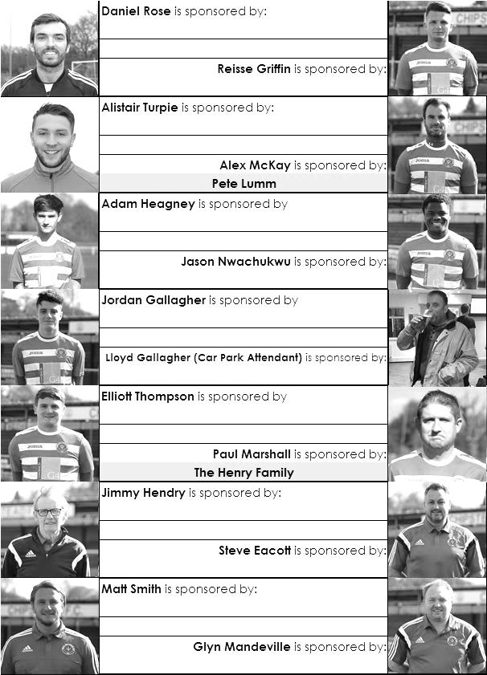

Sponsorship costs just £40 and it is easy to do. Just select a player who has not been previously sponsored and let a Committee Member know that you would like to sponsor them. Beware though. Until we have received the money it is possible for someone to jump in front of you, so don’t delay, sponsor today!
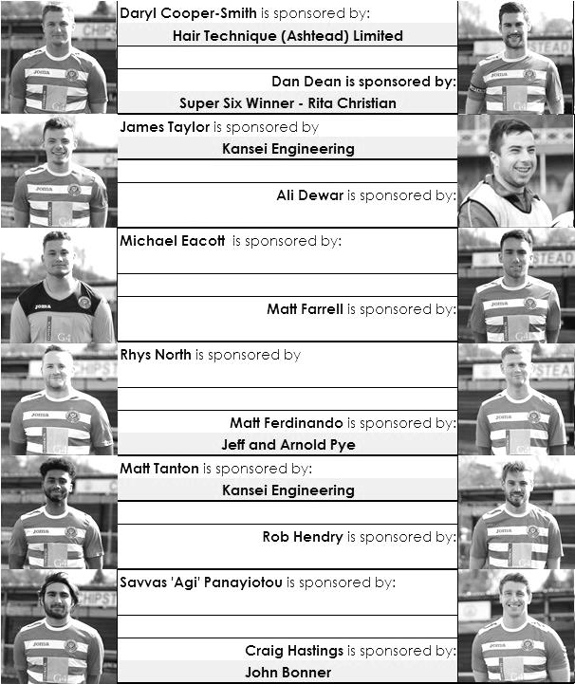

Seasonal Summary

It was always going to be a challenge, matching or improving on last season’s fourth place finish. However, as I write this, we still have a shot at doing just that and adding the League Cup to the Trophy Cabinet once again.

With the addition of two newly relegated Step Four teams in Walton & Hersham and North Greenford United, along with the reigning Champions Hartley Wintney we needed a strong side to compete, yet before the season had started we had lost scoring legend Kyle Hough to Horley Town and strong midfielder Bentley Graham to Whyteleafe with very few new faces on show. Sam Robinson returned to the team but didn’t last long, while of the new faces only Jack Watret was selected for the opening match of the season, a trip to newly promoted Bedfont & Feltham. It would be the only match he would play for the club as he struggled.

And so did our team in the opening half, conceding early and then letting in a second just after the half hour. This was going to be a really bad start to the season if we didn’t sort things out urgently. I have no idea what happened in the dressing room at half time, but what followed was quite simply one of the most incredible forty-five minutes ever witnessed in club history as we got back into the match quickly with two smart goals and the home side simply fell apart as we went on to score nine times in the second period with Daryl Cooper-Smith and Matt Farrell both scoring hat tricks as the home side were completely devastated. Club records tumbled as almost every attack ended with the ball in the Bedfont & Feltham net. What we didn’t know at the time was that the opposition were going to spend most of the season at the foot of the table, but it was still an impressive start.

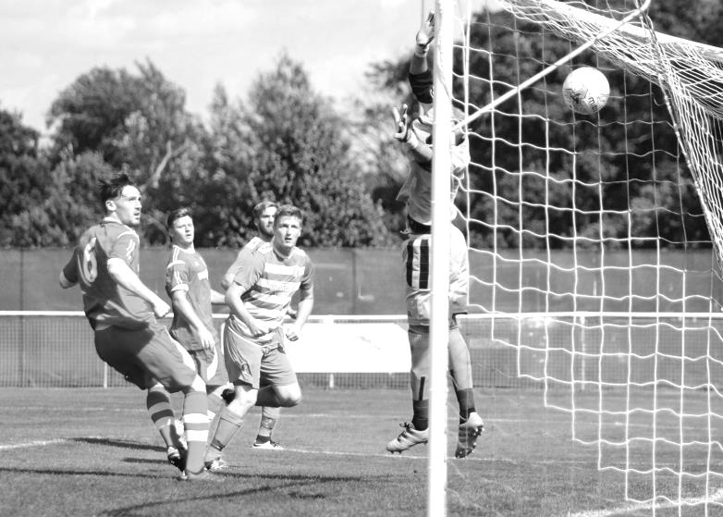
However, we had a real shock just five days later at home to Gravesham Borough in the F.A. Cup, finally building a 2-1 lead against a team that were down to ten men by this stage, only to see them equalise in the 88th minute.

Daryl Cooper-Smith opens the scoring against Gravesham Borough

With a midweek replay in Kent suddenly looking very likely we managed to score three in the closing moments with a debut goal from another new face Jordan Gallagher, who had only been on the field for moments and became one of the quickest scorers for the club as a result. He had joined us from Leatherhead along with Adam Heagney and both would prove to be valuable members of the starting eleven as the season progressed.

Unfortunately the next week would be nothing short of disastrous as we would suffer three defeats, go out of the F.A. Cup and lose Elliott Thompson to a season long injury. This happened at Windsor where we led but lost 2-1 in the final minute and a similar story occurred at Faversham Town after we had led the Ryman South promotion favourites for 65 minutes before being caught out by a wind assisted free kick from over thirty yards out and a deflected own goal.

In between these we crashed 5-1 at home to a rampant C.B. Hounslow United, last year’s First Division Champions. They were excellent on the night and it is still a shock to see them as low as they are in the table. I am sure they will be a team to watch next year once they are settled in at their new ground. As it turned out though, this would be our only League defeat at home until March.

Defeat at Faversham left us with a home League match against the third of the promoted teams Abbey Rangers; a team we would see plenty of this season. Following a 9-2 win and a 1-5 defeat to the other two promoted teams, it was hard to know what to expect here. However, an early sending off for the visitors made our task easier and we ran away with it in the end by seven goals to one with Cooper-Smith scoring another hat trick to maintain his electric start to the season.

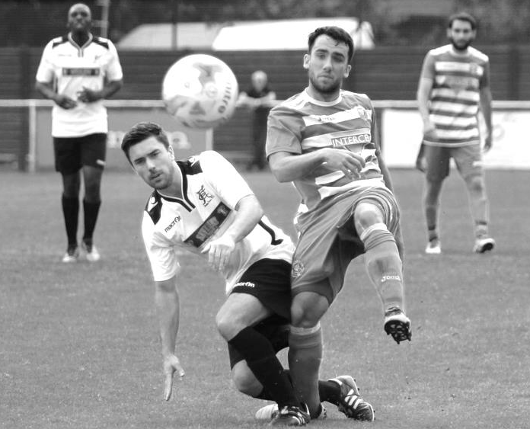
We were nothing if not unpredictable at this stage of the season and a low water mark was set just three days later in a Friday night evening match at Wibbandune where we were a little unfortunate to be behind to an early goal at the half but we just never got going and subsided to a 5-0 defeat to Colliers Wood, by some distance the worst performance in years by this club.

Every game was different and just three days later we were handing Horley Town a comprehensive 3-0 defeat, restricting former striker Hough to a couple of long range efforts throughout the match.

Matt Farrell scores our third goal v Horley Town

Two more from Cooper-Smith in that match left him on 11 goals from just seven matches, but you never knew what else you were going to get from our boys from one day to the next! One thing was clear. We were going to be bang in the middle of the table at this rate as rumours circulated that under the word “Inconsistency” in the new Oxford English Dictionary they were going to put a picture of our team!

Abbey Rangers were next up in the League Cup and this is where the trouble really started. We led 1-0 in a match where we were more in charge than we had been during the 7-1 rout, but we had a second goal disallowed for a very odd offside decision and when Matt Tanton conceded a foul as the opposition broke, things got a bit nasty with a full on mass brawl on the field of play. It led to three red cards, two for Abbey Rangers, but for us Daryl Cooper-Smith was going to miss three games for his part in the argument, even though he was protecting other players in the team. Our eventual progress in the competition that night was almost forgotten.

An uninspiring 0-0 draw followed at home to Camberley Town before we recorded a good 4-1 win at Badshot Lea’s temporary home ground of Ash United. We scored early against a team right down at the foot of the table, but it was level at half time and It took us a while to eventually break the resistance with our fourth goal coming from a most unlikely source as Assistant Manager Matt Smith took the field for the final moments and squeezed a shot past the home keeper in injury time! (see below)

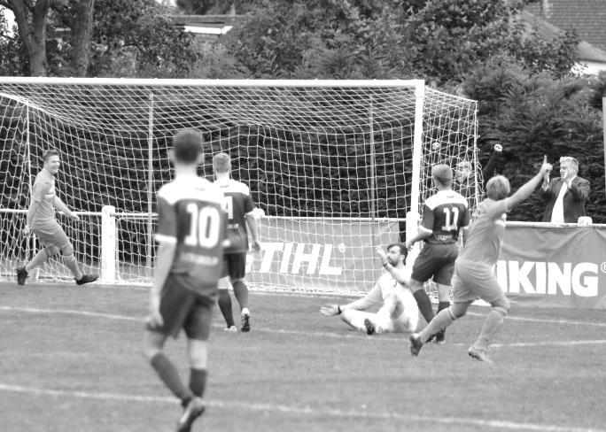
Knaphill had finished strongly last season and looked like they would be dangerous again but we produced one of our best performances of the season to defeat them 4-0 in a game where Reisse Griffin scored twice while Tom Neale and Matt Farrell scored the others.

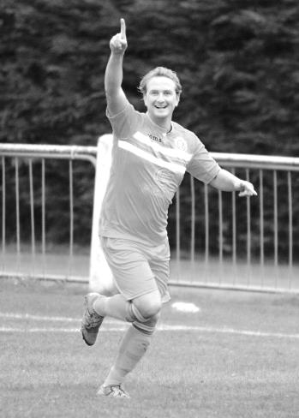
So how good were we? We were beginning to improve our consistency but next had to visit Woking Park, a venue where we hadn’t even scored on the previous two visits and against a team that had opened up with eight straight League wins. We may not have been at our sharpest that evening but Westfield were mightily impressive as we chased shadows and were lucky to turn around just two goals in arrears. An early close range

strike from Neale made the game competitive but the 2-1 defeat flattered us.

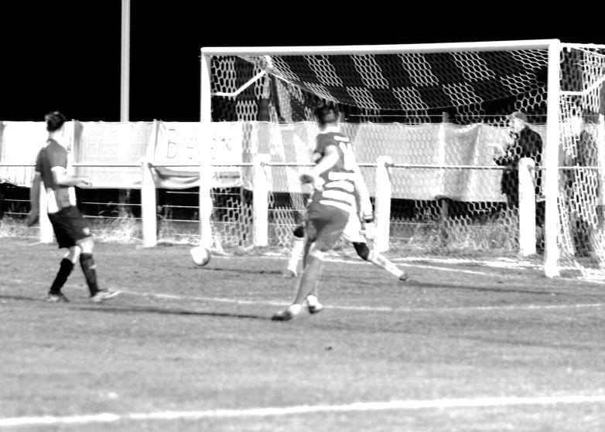
Faced with a trip to Stompond Lane next, a venue where we had conceded eight on our previous visit some years previously, we needed to stay strong and we turned around a goal to the good after Alex McKay had found the net, but we couldn’t hold on, drawing 1-1 and the Swans preserved their unbeaten home league record which remained untarnished this season until earlier this week.

Still, it was a good point and goals from Rob Hendry and Neale enabled us to secure a fairly comfortable win at Farnham Town before we visited Hanworth Villa for a Second Round League Cup tie. Hanworth were above us in the table and looked a big threat under the Management of former League player Rufus Brevett. However, they hadn’t planned on Cooper-Smith belting the ball in from thirty yards from wide out. It looked like it would be the winner until a late equaliser forced extra time and Alex McKay headed us back in front before a Matt Farrell penalty and Jordan Gallagher volley saw us through 4-2 in the end.

Jordan Gallagher scores our fourth goal against Hanworth Villa with a fine volley

Frustratingly, before the match we had an issue with Neale who refused to go on the bench and then promptly left the club to join Hanworth Villa. There have been times this season when we have missed him, but I think it was the right decision to let him go. At our club you have to buy into the team mentality and this wasn’t always apparent with Tom, especially when you disrupt the team just before an important match.

Unfortunately we suffered another last minute defeat the following Saturday when North Greenford defeated us 2-1 but Craig Hastings’ first goal for the club was sufficient to defeat Bridon Ropes in the First Round of the F.A. Vase seven days later.

It was our turn for a last minute equaliser as Matt Ferdinando steered in a low free kick in injury time to pinch a 1-1 midweek draw at Raynes Park Vale, which was quite an achievement as we only had one fit outfield player and an injured keeper on the bench that evening! We were back to a stronger line up at Guildford City on the Saturday as Hendry and Farrell were on the mark in a 2-0 win. It made a change for Hendry as he had been in goal for us on his previous visit to the Spectrum!

A narrow win against Sutton Common Rovers, our ninth in a row, was soon forgotten as

we departed the F.A. Vase against Abbey Rangers in a match spoiled by fussy officiating and a harsh early sending off for Reisse Griffin. Despite the handicap we still took the lead but couldn’t hold on and went 3-1 behind, although nearly pulled out a great comeback, reducing the score to 3-2 and having a goal bound shot blocked on the line by a hand, something else missed by the official that day.

We responded well by defeating Windsor 2-0 at High Road just two days later and although we trailed early at home to Bedfont Sports it wasn’t for long as Cooper-Smith produced a great individual effort to equalise within a minute and we literally ran away with it 5-1 in the end. Worryingly though, we threw a 2-0 lead away at home to AFC Hayes, allowing them to secure an unlikely 2-2 draw after we had dominated the first 70 minutes of the match.

The League Cup third round was next as we faced a visit to Worcester Park, a venue where we had crashed heavily in 2012. We went into the match with four players suspended, but fortunately Cooper-Smith wasn’t one of them. He became the first player in nearly twenty years to score four times in a match as we cruised to a 6-3 win to reach the Quarter-Finals, bringing his individual tally to a most impressive 25 goals in 21 appearances. We followed this up with a comprehensive 3-0 win over our Ryman League landlords Chipstead in the Surrey Senior Cup, in a match that also doubled as the tenth Dave Wilson Trophy. This had been intended for pre-season, but the F.A. decision to start the F.A. Cup early had led to our opening League match being brought forward and our traditional curtain raiser had to be deferred. It was our third win in a row, marking our fourth win in the ten competitions.

Daryl Cooper-Smith scores his fourth and our sixth goal at Worcester Park

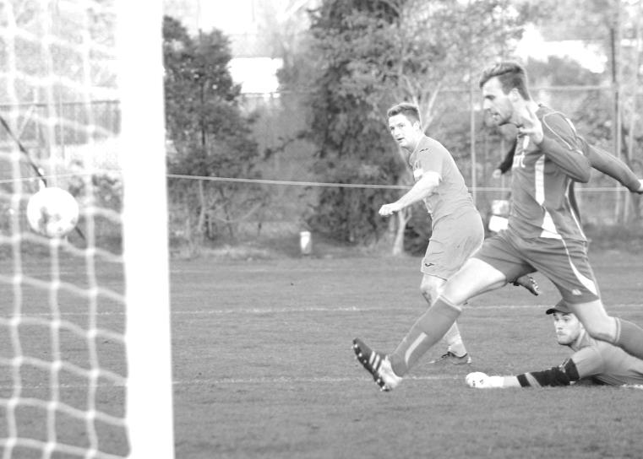
Unfortunately the rest of December was disappointing. We travelled in good heart to the leaders Hartley Wintney and led there through Matt Farrell before two harsh decisions against Matt Tanton left us down to ten men once again. Two fantastic free kicks then sealed our fate as we went on to lose 3-1.

We nearly lost again three days later as we dominated much of the proceedings against Hanworth Villa, but conceded, typically to Neale, before fighting back, although we left

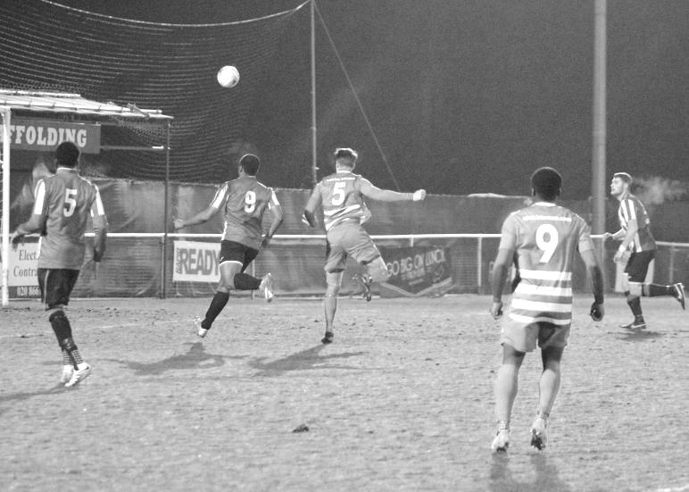
it late with Gallagher’s strike from the edge of the box squirting through a group of players for an equaliser in a 2-2 draw. We were back to winning ways on the Saturday as we built a good 2-0 lead over relegation threatened Chertsey Town but in echoes of our recent match with AFC Hayes, they changed their shape at 2-0 down and we were mighty fortunate to get away with a narrow 2-1 win by the final whistle. Our Christmas fixture was frustrating as Raynes Park Vale came for a point, but an 85th minute strike from Rob Hendry looked to have broken the resistance, only for us to concede an injury time equaliser. This was maybe only fair though as we had done the same to them at Grand Drive in October.

The New Year opened with a 3-2 win over Spelthorne Sports but we trailed at half time and a three goal burst was required to turn it around in the second half, with a late goal for the visitors making for another nervy High Road ending.

Guildford City ended our run in the Surrey Senior Cup by two goals to one, although we returned the favour seven days later in the League with a textbook Hastings header ensuring the points.

Craig Hastings scores the only goal in the League match against Guildford City

In between we lost to an early goal at Hanworth Villa, the first time in nine visits to the Ranch where we hadn’t been leading at some point, and after a small break we conceded a late penalty to lose 1-0 at AFC Hayes, a venue where we had won 7-0 just nine months previously.

A lack of goals was beginning to hurt us as we visited Stompond Lane for a League Cup Quarter-Final with Walton & Hersham and an unfortunate own goal from McKay left us up against it. However, there was still time to fight back and Ferdinando took a Hendry cross in stride to equalise before Gallagher cut in to score from distance right on half time. A third goal followed early in the second half as we took full control in one of our better performances of the season, only spoilt by Ferdinando’s skied penalty which would have given him his first hat trick for the club.

This appeared to kick start our season after the December malaise and we would go on

to win our next five matches, all in the League. Firstly, we recovered from some suspicious offside decisions which left us trailing to Badshot Lea but we fought back to win 4-2 before taking Chertsey Town apart on their own patch by three clear goals. It was only down to the outstanding performance of their stand in keeper that this didn’t end up as seven or eight as we secured our fourth straight win at Alwyns Lane.

The next win was equally impressive as suspensions left us with just one regular defender available, so Reisse Griffin dropped back alongside Dan Dean and we defeated CB Hounslow 2-0 at their temporary ground of the Orchard with goals from Cooper-Smith and Ferdinando. Four days later we had a stronger team available and it was just as well as we hosted Westfield. A thirty yard strike from Cooper-Smith sent us on our way and despite conceding an equaliser to former Salt James Cottee our second half pressure told and Ferdinando scored what proved to be the winner. This might be an important win if ever we were to come up against Westfield later in the season.

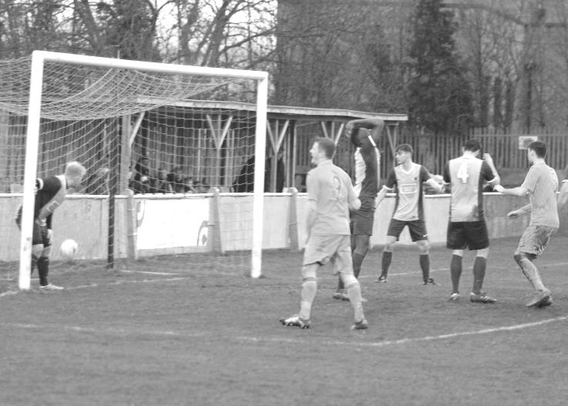
The final victory in the sequence required us to dig deep and a great dummy by Cooper-Smith totally confused the defence with Dan Dean forcing the ball over the line for a 1-0 win on our first visit to Abbey Rangers. Maybe equally surprisingly all twenty-two players remained on the field!

Since then things haven’t been quite so impressive. In the nine League matches that followed we conceded first in each of them. The first of these matches was against Spelthorne Sports where the game was spoilt by an abysmal refereeing performance. But a late Dean equaliser secured a 2-2 draw with only a brilliant save denying Cooper-Smith a winning goal in injury time.

Dan Dean scores our second equaliser at Spelthorne Sports

Then seven days later we faced Walton & Hersham where a smart Gallagher finish equalised a borderline penalty for the visitors.

We even trailed to the bottom club Bedfont & Feltham three days later, but it should be remembered that we had also trailed to them on opening day and we fought back convincingly. This was also the case at High Road as Rob Hendry and Agi Panayiotou scored to turn it around, but it required late goals from Hendry and Farrell to give us a flattering 4-1 win.

We then made our third visit of the season to the Orchard for a match against Bedfont Sports as their new 3g surface wasn’t quite ready. Yes, we went behind again but an

unfortunate own goal off a defenders chest gave us the spark before a sending off for the opposition, followed by the bizarre sending off of a spectator, later confirmed as a Bedfont official, and two late goals gave us the win.

So we went into the Hartley Wintney match in good form really. However, being unbeaten in ten matches and seventeen matches without defeat at High Road counted for little as we conceded just before half time and our pressure couldn’t get through. We were missing Cooper-Smith for this match, the third time in a row he had been suspended for the meeting of these two teams as he completed his four matches out. Fortunately he was back for the big match against Windsor in the League Cup Semi-Final which was a tight encounter, but was decided by two goals in our favour just before half time after Cooper-Smith broke in from the left to cut back for Ferdinando to score before a Hendry cross from the right was headed in at the far post by Gallagher. We had a Cup Final to look forward to for the first time since 2013!

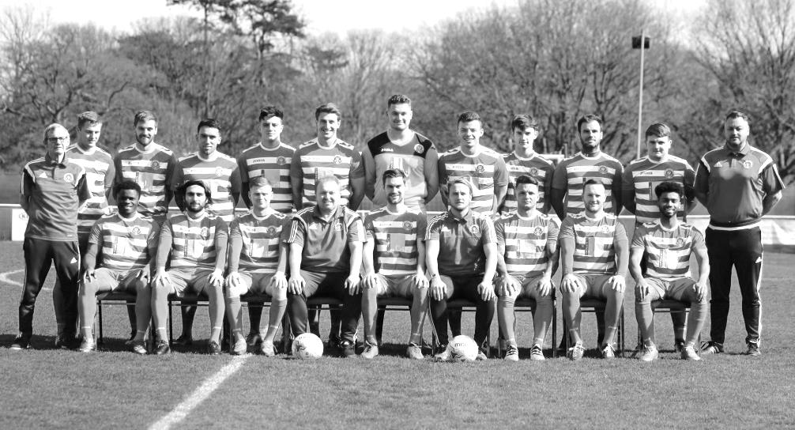
Against Farnham on the following Saturday we had to fight back twice through McKay and Griffin for a 2-2 draw but Camberley were too strong for us a week later and won 2-0. It looked like we might lose this one too as we conceded just after the hour mark but a quick equaliser from Farrell paved the way for Heagney to register his first goal of the season; an absolute screamer from over thirty yards that flew in off the far post and deserved to win any match.

The less said about our Good Friday defeat to Colliers Wood the better although our trip to Horley on Monday was an improvement as we won 2-1, but overall it has been an interesting season with cup runs and another healthy League position on the cards. I wrote last year that “If we can keep a similar squad next year, and can keep a handle on our discipline, we have every chance of a title run next season.” It’s fair to say that we didn’t quite do either, which is probably why we are just a few points short of where we could have been once again. Still, on balance it’s been another good season I reckon!

Surrey Senior Cup
Third Round
Whyteleafe | 2-0 | Egham Town
Badshot Lea | 0-2 | Raynes Park Vale
Epsom & Ewell | 1-2 | Guildford City
Dorking Wanderers | 1-1 8p7 | Sutton Common Rovers
Chertsey Town | 1-0 | Kingstonian
Woking | 2-0 | Leatherhead
Merstham | 5-1 | Walton & Hersham
Tooting & Mitcham United | 0-1 | Knaphill
Quarter Final
Guildford City | 2-1 | Raynes Park Vale
Chertsey Town | 0-3 | Dorking Wanderers
Merstham | 2-1 | Whyteleafe
Woking | 3-1 | Knaphill
Semi Final
Guildford City | 1-2 | Woking
Dorking Wanderers | 2-3 | Merstham
Final @ Woking F.C. 3rd May
Woking | V | Merstham

F.A. Vase
Fifth Round – 28th / 29th January
Cleethorpes Town | 3-2 | Atherton Collieries
Southall | 4-2 | Exmouth Town
Bromsgrove Sporting | 2-1 | Bristol Manor Farm
Crowborough Athletic | 3-6 | Coleshill Town
Hinckley AFC | 3-4+ | Buckland Athletic
Newport Pagnell Town | 3-2+ | Sunderland RCA
Ely City | 0-3 | Sporting Khalsa
Team Solent | 2-5 | South Shields
Quarter - Final – 18th February
South Shields | 6-1 | Newport Pagnell Town
Southall | 2-5 | Cleethorpes Town
Bromsgrove Sporting | 2-0 | Buckland Athletic
Coleshill Town | 2-0 | Sporting Khalsa
Semi - Finals - two legs – 11th & 18th March
Coleshill Town | 1-2 | South Shields
South Shields | 4-0 | Coleshill Town
Bromsgrove Sporting | 1-1 | Cleethorpes Town
Cleethorpes Town | 1-0 | Bromsgrove Sporting
Final @ Wembley Stadium 21st May
Cleethorpes Town | V | South Shields

CCL Premier Division Club Directory
ABBEY RANGERS Telephone: 01932-422962 - Ground: Addlestone Moor, Addlestone, Surrey KT15 2QH - Colours: Black & White Stripes/Black/Black

A.F.C. HAYES Telephone: 0208-845-0110 - Ground: Farm Park, Kingshill Avenue, Hayes, Middx. UB4 8DD - Colours: Blue and White Stripes/Blue/Blue

BADSHOT LEA Telephone: 01252-320385 - Ground: Ash United FC, Shawfield Stadium, Youngs Drive, Shawfields Road, Ash, Hampshire. GU12 6RE - Colours: Claret/White/Claret

BEDFONT & FELTHAM Telephone: 0208 890 7264 - Ground: The Orchard, Hatton Road, Bedfont, Middx TW14 9QT - Colours: Yellow & Blue/Blue/Blue

BEDFONT SPORTS Telephone: 0208-831-9067 - Ground: Bedfont Sports Club, Hatton Road, Bedfont, Middx TW14 8JA - Colours: Red & Black Hoops/Black/Red & Black Hoops

CAMBERLEY TOWN Telephone: 01276-65392 - Ground: Krooner Park, Wilton Road, Camberley, Surrey. GU15 2QW - Colours: Red & White Stripes/Blue/Red

CB HOUNSLOW UNITED Telephone: 0208 890 7264 - Ground: The Orchard, Hatton Road, Bedfont, Middx TW14 9QT - Colours: Green/Black/Green

CHERTSEY TOWN Telephone: 01932-561774 - Ground: Alwyns Lane, Chertsey, Surrey. KT16 9DW - Colours: Royal Blue & White Stripes/Royal Blue/Royal Blue

COLLIERS WOOD UNITED Telephone: 0208-942 8062 - Ground: Wibbandune Sports Ground, Robin Hood Way, Wimbledon. SW20 0AA - Colours: Blue & Black Stripes/Black/Black
EPSOM & EWELL Telephone: 01737-553250 - Ground: Chipstead FC, High Road, Chipstead, Surrey. CR5 3SF - Colours: Royal Blue & White Hoops/Royal Blue/Royal Blue

FARNHAM TOWN Telephone: 01252-715305 Ground: Memorial Ground, Babbs Mead, West Street, Farnham, Surrey. GU9 7DY Colours: - Claret & Sky Blue /White/ Claret & Sky Blue

GUILDFORD CITY Telephone: 01483-443322 - Ground: The Spectrum, Parkway, Guildford, Surrey. GU1 1UP - Colours: Red & White Stripes/Black/Black

HANWORTH VILLA Telephone: 0208-831-9391 - Ground: Rectory Meadows, Park Road, off Hounslow Road, Hanworth, Middlesex. TW13 6PN - Colours: Red & White Stripes/Black/Black

HARTLEY WINTNEY Telephone: 01252-843586 - Ground: Memorial Playing Fields, Green Lane, Hartley Wintney, Hants RG27 8DL - Colours: Orange & Black/ Orange /Orange

HORLEY TOWN Telephone: 01293-822000 - Ground: The New Defence, Anderson Way, Court Lodge Road, Horley, Surrey. RH6 8SP - Colours: Claret & Sky Blue/Claret/Claret

KNAPHILL Telephone: 01483-475150 - Ground: Brookwood Country Park, Redding Way, Lower Guildford Road, Knaphill, Surrey. GU21 2AY - Colours: Red/Black/Red

NORTH GREENFORD UNITED Telephone: 0208 422 8923 - Ground: Berkeley Fields, Berkeley Avenue, Greenford, Middx UB6 0NX - Colours: Royal Blue & White/Royal Blue/Royal Blue

SUTTON COMMON ROVERS Telephone: 01932-866386 - Ground: Sutton United FC, Gander Green Lane, Sutton, Surrey SM1 2EY - Colours: Yellow/Black/Black

RAYNES PARK VALE Telephone: 020-8540-8843 - Ground: Prince Georges Playing Field, Grand Drive, Raynes Park, London. SW20 9NB - Colours: Blue/Blue/Red

SPELTHORNE SPORTS Telephone: 01932-961055 - Ground: Spelthorne Sports Club, Staines Road, Ashford Common, Ashford, Middx. TW15 1RY - Colours: Light & Dark Blue/Dark Blue/Light Blue

WALTON & HERSHAM Telephone: 01932 245263 - Ground: Stompond Lane, Walton on Thames, Surrey KT12 1HF - Colours: Red/Red/Red

WESTFIELD Telephone: 01483-771106 - Ground: Woking Park, Kingfield Road, Woking, Surrey. GU22 9BA - Colours: Yellow/Black/Black

WINDSOR Telephone: 01753-860656 - Ground: Stag Meadow, St Leonards Road, Windsor, Berks SL4 3DR - Colours: Red/Red/Red

Final words
Looking back almost ten years, I wrote my first match programme for the club in 2007. We had a new Chairman and Vice-Chairman, two new young strikers by the names of Hough and Burns and a fairly unproven but keen Manager in Lyndon Buckwell. It was also that summer when I put the finishing touches to the club History Book, Two Legs Not Four and I recall writing about whether these new faces would provide us with a bright new future.

Ten years on, they have all gone but it is pleasing to note that so many supporters remain from that time, despite the trials and tribulations the club has faced in its attempts to return to the Borough.

I really had hoped to bring some positive news about our search for a ground by the end of the season. Many of you were aware that we were in discussions with an organisation within the Borough, but few of you will have known that we were also looking at another site, leased to the Old Suttonians but currently in a derelict state. They appeared interested, but in the last month have confirmed that they are now not going to proceed with us due to the timescales. It would have been nice had they actually known our timescales as we never even got to the point of talking about them in the first place!

All of this is symptomatic of the troubles we have been facing as a club for the past 29 years. Yes, 29, as we actually sold West Street in 1987, even though we didn’t leave it until 1993. Quite simply though, not enough people out there care enough about our club. There may be no others of our standard in the Borough of Epsom & Ewell, but dotted across the South East they are almost ten a penny as these new Youth based organisations come through to our level. It is beginning to look as though the number of established clubs will decrease shortly, with Kingstonian and Walton & Hersham amongst other clubs that face a serious battle to survive due to the impending losses of their ground.

Although other discussions continue with other parties, it is time to face the facts. We are in serious trouble as a club. This might seem odd when you look at our League position with a League Cup Final on the horizon, but our chances of sourcing a site in time to still have some money left to afford to build on it are significantly lower as a result of the recent developments, or more accurately non-development. I wrote last season that “it’s fair to say that if we do not have our own site confirmed within 12 months, we as a Committee may have to make some very unpopular decisions to keep the club alive in the future”. Whilst we have not quite reached that stage yet, we are not far away if nothing changes in the next twelve months.

Now is the time for supporters to help by spreading the word. It is quite possible that we may have to look towards the generosity of a private land owner. If you know ANYONE within the Borough that might be prepared to consider leasing out a portion of their land, we would like to hear from you now. There may be plenty of greenery in our Borough but most of it is privately owned and this is where we need some help from YOU! It’s just not possible to leave it to others anymore if this club is to return. Ask your friends, colleagues, lapsed supporters. Do they have any contacts with a football friendly land owner?

Back on the field, It is pleasing to report that the club has had another successful season. With the prospect of extra promotion places from Step Five for 2017/18 only, although exactly where these will be has yet to be determined so don’t get your hopes up just yet, we are in a prime position to challenge next year. Glyn and the boys have done some great things this season and while disciplinary issues continue to haunt us, we are not the only club affected and it is concerning that the Surrey F.A. is more interested in showing off pictures of its new building, (raised by funds and fees from its clubs, I should remind everyone) and how wonderfully inclusive and diverse it is, that it has taken the eye of the ball, both literally and metaphorically when it comes to its established clubs. We have already lost one of the big clubs with a great history this season in Dorking, and as I advised earlier, others may follow soon. If you get asked at any time to fill out one of the Surrey F.A. surveys, designed by them as a self-congratulatory exercise to tell them how great a job they are doing, please ensure that you put them straight.

The quality of the officiating also appears to have hurt us once again this season. I’ve been watching

football at this level for over 35 years now and there was a time not so long ago when everyone would talk about how bad a particular official was. Nowadays the conversations relate to how good a particular one was; Michael Begley against Westfield showing everyone else how to control a football match between two of the top clubs in the division that day. It’s sad that it has come to this.

Many cards have been sent our way and not just at Christmas, as every kicking the ball away offence of ours appears to be punished, while it seems to be ignored when the opposition do it. Matt Ferdinando picked up a card for picking the ball up at Horley on Monday, even though he threw it back to the opposition, who moments before had stood directly in front of the ball to prevent us from taking a free kick of our own, naturally with no penalty. While consistency is often impossible on the judgement of what is and what isn’t a foul, there are areas which could be improved as this Respect initiative looks more and more as though it is a one way street. We could improve in this area ourselves still, but I share the players’ frustrations with many of the issues they have faced. On a side note, I recently received a Linked In social media friend request from one of our referees who will remain nameless. I declined.

Despite all this, we have STILL made it to the Cup Final with a very realistic shot at a top four place and the Vase exemption that it would bring. It is therefore to our Manager, Staff and Players that I give my first thank you. Glyn is close to reaching 150 games as Manager and assuming he is still with us this time next season, as we all hope, he will become the fourth longest serving Manager in our history. We have seen some great stuff on the field this year and although we have picked up few points from the teams around us at the top, all of the defeats have been narrow ones.

Our Chairman Pete Beddoe has continued to be both Chairman and Secretary, the latter in particular being a fairly thankless task for much of the time. A good Secretary is like a good Referee in that they are rarely noticed, but it is a pivotal job. Pete is regularly at matches hours before most of us have even left to get to the game and is extremely conscientious. Likewise Steve Dyke has worked wonders on the finances, enabling the club to run without waste. What is concerning is the amount of time Steve has had to spend checking up the figures at the Surrey F.A. after we have on at least two occasions that I am aware of, been given wrong figures in terms of yellow cards by them. Incredible really!

Other people that have helped this season include Paul Marshall who has also been very reliable, hardly missing a match this year, covering the kit and the meet and greet in the clubhouse. Inside the clubhouse, which you will all have noticed underwent a nice refurbishment during the summer. We have also been able to provide hot food for the players and officials which is a real benefit, especially on a cold night. Maggie Beddoe has been responsible for much of this with Steve Dyke as a willing back up. If you want to find out how good the hospitality is, just sponsor a match!

On the subject of sponsors, we have had two kit sponsors over the season which started with Intercem through Malcolm Shelbourne and is now covered by G4 Contracts Limited. In addition we have had a large chunk of sponsorship from The Building Shop, Bookham and Kansei Engineering. Some of you have sponsored matches on a couple of occasions, like our Club President Stella Lamont and Nigel and Janice Pond, while Membership Secretary Mel Tough is covering the cost of new Club Badges and the yellow away kit. Again we are most grateful for all donations and contributions.

In terms of the programme Gemma Jarman has also been extremely reliable once again with some superb photos, while The Print Centre has also been reliable and reasonable with their costs. It is disappointing that I have been unable to produce programmes of the size we have seen in years gone by, but cost constraints are inevitable in the position we face. I hope there is still enough of interest for you.

I would also like to thank our Landlords Chipstead FC for their support in these difficult times, and mostly I want to thank those of you that are regular supporters of our club. Some have recently been seduced by the frankly shocking practice of selling cheap season tickets over at the ground which shall remain nameless this season (they had a bit of a cup run). Their actions hurt the local clubs who are already struggling for support in the first place and bearing in mind that a minimum ticket price of £15 for a match exists in the National League, their reduced season tickets must be in a very grey area legally. Ultimately, though, we have to accept that some clubs will push the boundaries and we have to find ways to compete, despite the lack of revenue from a clubhouse. This is regrettably our only choice or we will die.

Combined Counties League Premier Division
Opponents All-time Records
incl Monday 17th  April | P | W | D | L | F | A | PPG | GD | Best  Win | Worst  Loss
Bedfont & Feltham | 2 | 2 | 0 | 0 | 13 | 3 | 3.00 | +10 | 9-2 | X
Spelthorne Sports* | 7 | 5 | 2 | 0 | 15 | 6 | 2.43 | +9 | 6-2 | X
Sutton Common Rovers | 12 | 9 | 2 | 1 | 30 | 14 | 2.42 | +16 | 4-0 | 1-4
Horley Town | 30 | 21 | 5 | 4 | 67 | 31 | 2.27 | +36 | 6-0 | 1-3
Abbey Rangers | 4 | 3 | 0 | 1 | 11 | 4 | 2.25 | +7 | 7-1 | 2-3
Bedfont Sports | 11 | 7 | 2 | 2 | 21 | 12 | 2.09 | +9 | 5-1 | 0-4
Knaphill | 8 | 5 | 1 | 2 | 17 | 9 | 2.00 | +8 | 4-0 | 1-2
Westfield | 20 | 12 | 3 | 5 | 42 | 32 | 1.95 | +10 | 6-1 | 0-4
Colliers Wood United | 23 | 14 | 2 | 7 | 45 | 34 | 1.91 | +11 | 4-0 | 0-5
Guildford City | 18 | 11 | 1 | 6 | 35 | 22 | 1.89 | +13 | 5-1 | 1-5
Farnham Town | 15 | 8 | 3 | 4 | 27 | 25 | 1.80 | +2 | 3-1 | 1-4
Badshot Lea | 19 | 9 | 3 | 7 | 39 | 36 | 1.74 | +3 | 4-1 | 0-4
Hanworth Villa | 17 | 8 | 4 | 5 | 38 | 27 | 1.65 | +11 | 5-0 | 1-4
Walton & Hersham | 52 | 25 | 11 | 16 | 105 | 99 | 1.65 | +6 | 8-0 | 1-9
Raynes Park Vale | 28 | 13 | 7 | 8 | 59 | 38 | 1.64 | +21 | 6-1 | 0-2
Camberley Town* | 90 | 38 | 22 | 29 | 158 | 125 | 1.51 | +33 | 9-1 | 0-4
Windsor | 50 | 20 | 12 | 18 | 92 | 90 | 1.44 | +2 | 4-0 | 0-6
Chertsey Town | 49 | 19 | 5 | 25 | 75 | 87 | 1.27 | -12 | 3-0 | 0-7
Hartley Wintney | 12 | 4 | 3 | 5 | 26 | 21 | 1.25 | +5 | 5-0 | 2-4
North Greenford United | 11 | 3 | 2 | 6 | 15 | 20 | 1.00 | -5 | 3-0 | 1-4
CB Hounslow United | 3 | 1 | 0 | 2 | 4 | 7 | 1.00 | -3 | 2-0 | 1-5
AFC Hayes | 10 | 2 | 3 | 5 | 18 | 18 | 0.90 | 0 | 7-0 | 0-3
* includes one abandoned match v Camberley and one loss on penalties v Spelthorne

Salts Super Six Predictor
The Salts Super Six Predictor is live again for today’s match and the tickets are on sale at today’s game to the left of the gate. The matches are to be played this afternoon.

The jackpot has already climbed to £386 which is fairly large and who knows how much higher it could rise!

The competition is easy to play! To win, you simply need to predict the results of six matches correctly from the three options, fill in the form and make sure it is back with our seller before the deadline on the ticket. The latest fixtures are shown below.

If you are a club regular, you just need to place your name on the sheet, although if you aren’t, then we’ll need a contact number from you too. We will announce any winners on the website within three working days, so don’t worry, we won’t miss you!

Please note that if there is more than one winner, the prize pot would be shared between the winners. All you need to do now is have a go, as many times as you like!

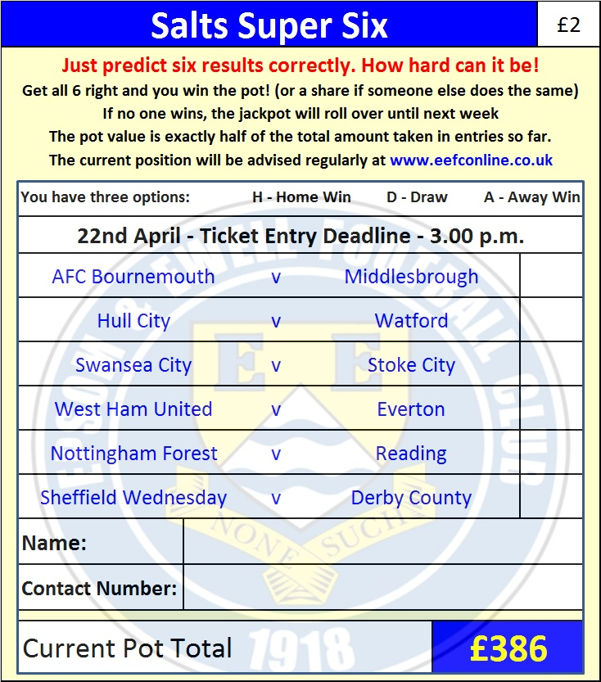

Good luck!

Combined Counties League – Premier Division
Saturday, 22nd April 2017 - Kick-off 3.00 p.m.

Epsom and Ewell  (Royal Blue & White hoops) | V |  | North Greenford United  (Red and White, Red, Red)
Squad | NUMBERS |  | Squad
Michael Eacott |  |  | James Harry
Adam Heagney |  |  | Tayo Davies-Coker
Matt Tanton |  |  | Josh Lewis-Evans
James Taylor |  |  | Guy Ansah-Palmer
© Dan Dean |  |  | Matt Travis
Savvas ‘Agi’ Panayiotou |  |  | Carl Bower
Jordan Gallagher |  |  | Daniel Vincent
Matt Farrell |  |  | Anthony O’Connor
Daryl Cooper-Smith |  |  | Alfie Cain
Matt Ferdinando |  |  | Sandro Costa
Reisse Griffin |  |  | James Simmonds
Jason Nwachukwu |  |  | Jamal Velinor
Craig Hastings |  |  | Charlie Conner
Rob Hendry |  |  | Kamal Akel
Alex McKay |  |  | Georgie Brown
Rhys North
Alistair Turpie
Matt Smith
Ali Dewar
Glyn Mandeville | MANAGER |  | Danny Vincent
Matt Smith | ASSISTANT
Steve Eacott / Alex McKay/  Jimmy Hendry | COACHES / PHYSIO |  | Colin Murphy /  Louise Hartley
REFEREE: J.Bolland
ASSISTANTS: R.Redman, R.Wells
Today’s match and Match Ball are kindly sponsored
By our Club President Stella Lamont

Thank You for your support this season!

We hope to see you at the Cup Final on 5th May
Don’t forget to order your tickets for the Coach!

